|  |  |
| --- | --- |
| [DRAFT]Global Business IntelliGence (GBI) Modern Data Architecture (MDA) Design Document | [DRAFT] This document describes the structures, methods and naming conventions used to build the Insight Modern Design Architecture (MDA)  Author: Finance GBI Team |

Contents

1 Business Intelligence Design Document 6

1.1 Executive Overview [Michael Greene] 6

1.1.1 Purpose and Scope 6

1.2 Getting Started [Alejandro Sanchez Arocha] 6

1.2.1 Databricks training 6

1.2.2 Python 7

1.2.3 GitHub 7

1.3 System Overview [Aaron Kyler] 7

1.3.1 Databricks SQL (SQL) 7

1.3.2 Excel ODBC connections 7

1.3.3 Notebooks (Data Science & Engineering) 7

1.3.4 Moving from SQL Server to Databricks 7

1.3.5 Environments 8

2 Environment 9

2.1 Tools 10

2.1.1 Azure Databricks Interface [Mark Dilly] 10

2.1.2 Databricks SQL Interface [Josiah Melcher] 19

2.1.3 Microsoft Azure Storage Explorer [Sanjay Tanneeru] 20

2.1.4 Github [Evan Matthews] 28

3 Access to Tools [Evan Matthews] 44

3.1 Databricks Workspace 44

3.2 GitHub 45

4 Naming conventions 46

4.1 Database naming [Mark Dilly] 46

4.2 Github Repo naming [Sanjay Tanneeru] 46

4.3 Databricks Job naming [Josiah Melcher] 47

4.4 Databricks Table and View naming [Mark Dilly] 47

4.5 Table and file locations 47

4.5.1 Physical table location [Mark Dilly] 48

4.5.2 Creates [Evan Matthews] 48

4.5.3 Updates [Aaron Kyler] 52

4.6 Column naming [Josiah Melcher] 52

5 Data 53

5.1 Tables 53

5.1.1 Table creation 53

5.1.2 Table updates and population (deltas) 53

5.2 External Data Sources [TBD] 53

5.2.1 activity 53

5.2.2 adobe 53

5.2.3 freshdesk 54

5.2.4 hr 54

5.2.5 marketo 54

5.2.6 sapecc 54

5.2.7 servicedesk 54

5.2.8 servicenow 54

5.2.9 TBD 59

5.3 BI Databases and Datasets 59

5.3.1 Finance [Mark Dilly] 60

5.3.2 Masterdata [Mark Dilly] 70

5.3.3 Microsoft [Sanjay Tanneeru] 93

5.3.4 Operations [Mark Dilly] 96

5.3.5 Sales [Mark Dilly] 103

5.3.6 servicenow [Mark Dilly] 127

5.4 Data Exports to outside systems [TBD] 127

5.4.1 Totango 127

5.4.2 TBD 128

5.5 Currency Conversion [Mark Dilly] 128

5.6 SoldTo Uniqueness [Mark Dilly] 130

5.7 Datalake (Blob) Storage [Done] 132

5.8 Repos Folders 134

5.8.1 Folder Conventions [done] 134

Repo folders are named in the following format 134

6 Jobs [TBD] 135

6.1 job notebook 135

6.2 Job configuration file 135

6.3 Job scheduling 135

6.4 Clusters 135

6.5 Performance 135

6.5.1 Streaming 135

6.5.2 Optimization 135

6.6 Failures and Troubleshooting 135

7 Reports [Done] 136

7.1 PowerBI Reporting 136

7.1.1 Data Models 136

7.1.2 Data refreshes 136

7.2 Paginated reporting 136

7.3 Workspaces [Mark Dilly] 138

7.3.1 :BI 138

7.3.2 :BI Accounting and Finance 138

This workspace contains report related to: 138

7.3.3 :BI Client Reporting 138

7.3.4 :BI CMD 138

7.3.5 :BI HR 138

7.3.6 :BI Marketing & e-commerce 139

7.3.7 :BI Models 139

7.3.8 :BI PM & Sales 139

7.3.9 :BI Operations 139

7.3.10 :BI Services 139

8 Data Science and Machine Learning [Joseph Abramson] 140

8.1 Use of Databricks 140

8.2 Personas 140

9 Appendix 144

9.1 Acronyms 144

9.2 Other Terms and Definitions 146

# Business Intelligence Design Document

## Executive Overview [Michael Greene]

This guide will serve as the overview and will set the stage on how to leverage the Modern Data Architecture here at Insight. There has been a concentrated effort to migrate from our on-premise SQL server to a cloud based architecture that will help us scale and deliver intelligent information to multiple teams across the company. While there is a significant change in how the information is stored in a logical naming convention, there is also a change in how we consume Databricks/Azure units from an infrastructure perspective. With the change from an organically developed environment with the on-premise SQL environment to that of Databricks & Azure, new controls will be put into place to safeguard from process over utilization or code that can compromise the environment. Naming conventions will also be enforced to ensure that others accessing the system will be able to easily identify data subject areas. To make sure that the code that is deployed meets our standards, peer reviews will be highly enforced and monitoring is in place to not only scale CPU utilization but to also make sure that the work is being carried out in the most efficient manner. You will find within the document overviews of the architecture how the two environments differ and the systems and tools that complement moving from ideation to deployment. Datasets will be created by the BI team and reports can be delivered via Direct Query, Microsoft Excel with ODBC connectivity or Power BI. This document also has overviews for the datasets that have been created by logical subject area and the reports that have been created centrally for both North America, APAC and EMEA.

The team is looking for feedback and input on what has been created to date. If there are issues or data integrity issues that are found please report them back to the BI team.

### Purpose and Scope

This document contains conventions, rules of thumb, top-level design criteria, and other methods the Business Intelligence team uses to build out databricks data structures, functions, and data processes for Insight.

## Getting Started [Alejandro Sanchez Arocha]

It is important to have some training and background before diving into the new environment. Below you will find some resource/tutorials that you should read thru or exercise before going on to the rest of the document. These should be considered “minimum” prerequisites before moving on to the environment.

### Databricks training

The following Databricks training is suggested:

<https://databricks.com/learn/training/home>

[Databricks self-paced training_CG.pdf](https://insightonline.sharepoint.com/:b:/r/sites/BusinessIntelligence/Shared%20Documents/General/Project%20Documentation/DatabricksMDA/Databricks%20self-paced%20training_CG.pdf?csf=1&web=1&e=khdguu)

### Python

Percipio offers a number of courses available on inside.insight.com. The below course or equivalent is suggested:

?

### GitHub

Percipio offers a number of courses available on inside.insight.com. The below course or equivalent is suggested:

Git and GitHub: Introduction

## System Overview [Aaron Kyler]

##### Tip

### Databricks SQL (SQL)

The Databricks SQL web application is modeled after SQL Server Management Studio and provides a familiar user experience for query writing. It does not allow windowed functions (e.g. RANK), however, other functions such as FIRST can often accomplish the same purpose. Displayed data and excel exports are limited to 64K lines, but larger results can be exported to csv files.

### Excel ODBC connections

Another way to export more than 64K rows from queries by embedding them into ODBC connections. These can be embedded into in Excel workbooks via Power Query.

### Notebooks (Data Science & Engineering)

SQL queries can be executed in both Python and SQL notebooks from queries written in Databricks SQL or other locations by embedding them into Excel. CSV files of up to 1M lines can be exported from notebooks.

### Moving from SQL Server to Databricks

Spark SQL is very similar to SQL server and is the most used tool in databricks. The syntax is based on My SQL and some functions and syntax differ from SQL server. A complete reference for spark SQL functions is maintained in <https://spark.apache.org/docs/latest/api/sql/index.html>. It can be executed in notebooks or in Databricks SQL queries.

#### Spark SQL Tips

There are a fair number of differences between Spark SQL and SQL server functions, and Spark SQL continues to grow and get more and better functionality. Here are a few notable best practice differences

##### Avoid windowed functions when possible

While windowed functions such as RANK() are available in Spark SQL, as of now they can impact performance because they are not supported by the new Photon engine that Databricks is able to use. The FIRST() function provides an alternative method for deduping data

##### Use CTEs in place of temp tables

Temp tables can be sometimes be useful in Databricks, but don’t provide as much potential performance improvement as they did in SQL server and in some cases could lower performance compared to using a single query. CTEs are often a better alternative and can easily be used to help with writing clean and efficient queries.

##### Specify selected columns

Only “SELECT *” when all columns are needed. Selecting more data than necessary can greatly increase query cost. To get the best performance and efficiency, narrow down selected columns in sub queries, temp tables, CTEs and outputs.

### Environments

Different environments are be used for each stage of the SDLC process.

#### DEV

Dev Data will be very different than production because it is generally pointed at test environments and does not tend to have full scheduling executed. Tables and schemas may vary from production due to unit testing and working changes. Unit testing should be performed in Dev to avoid impacting prod and in progress testing.

#### FQ

May contain some data from production systems, but only to be used for testing purposes as data may not exactly match production. Code changes will automatically be merged to FQ after they are committed to a Dev branch.

#### PRD

Production data – Should be used for all production output purposes. Changes to production objects must go through CAB and weekly deployment process.

# Environment

The environment uses the latest Microsoft Azure cloud technology and toolsets. Data is stored in databricks SQL tables as well as Blobs. The majority of coding is done in Python using PySpark and Pandas APIs. Github provides software version control.

Below is the target High-Level Architecture Reporting

## Tools

### Azure Databricks Interface [Mark Dilly]

Azure Databricks is a data analytics platform optimized for the Microsoft Azure cloud services platform. This environment provides a development environment for storage and access capabilities we formerly used in Microsoft SQL.

Reference doc: <https://docs.databricks.com/workspace-index.html>

There are 3 environments dev, fq, and prod. All of these can be accessed thru the following url:

***westus.azuredatabricks.net***

Select the appropriate environment:

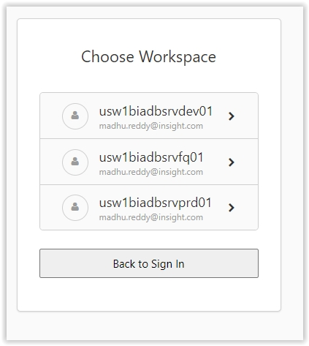

You will have to enter your credentials which are validated against Insights Active Directory entries in the cloud:

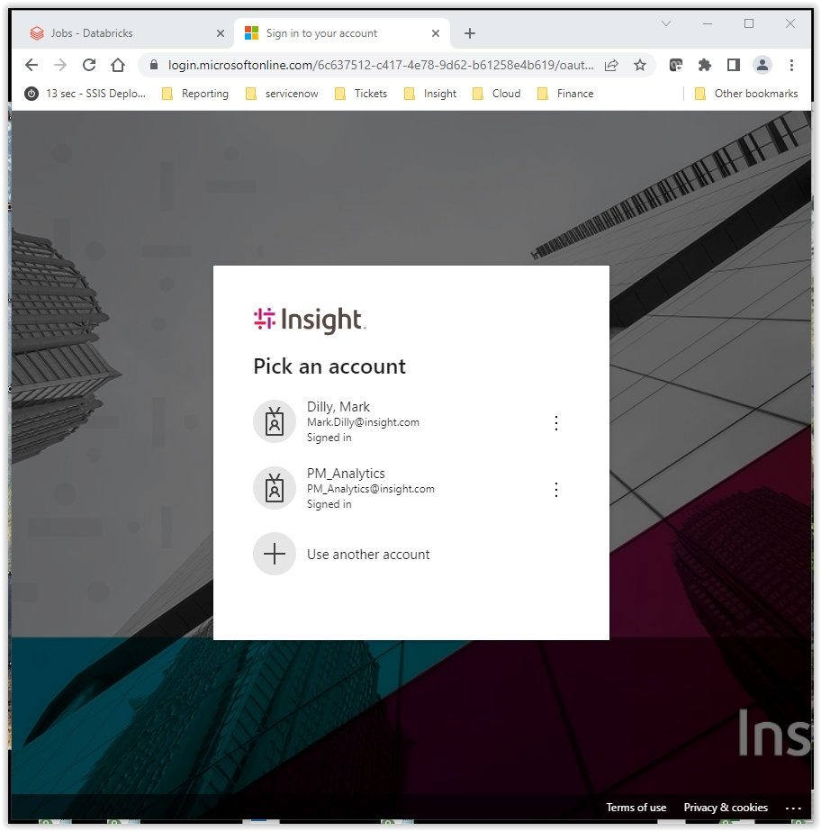

Once granted entry, you have access to many tools, including:

Data Science & Engineering

Data Science & Engineering

Machine Learning

Databricks SQL

Workspace

Repos

Data

Compute

Jobs

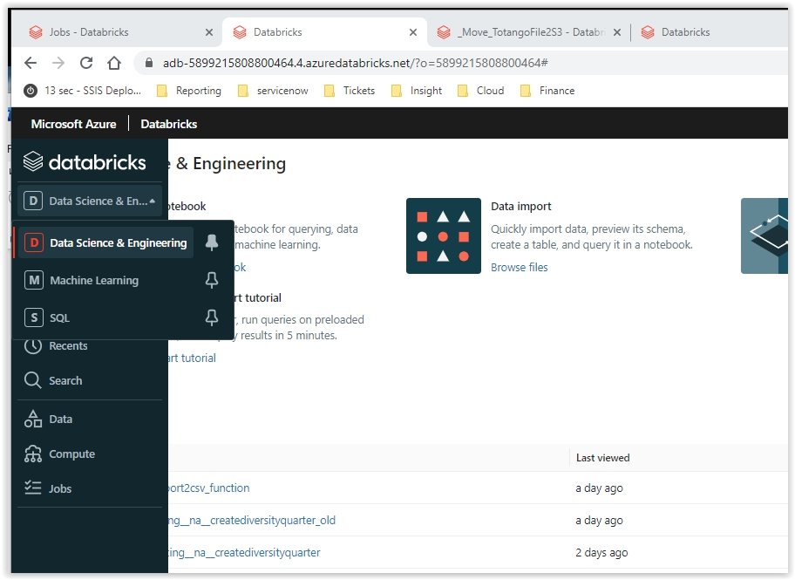

***Workspace*** is where you can create folders, notebooks in your own personal space

It also displays the current environment you are logged into at the lower left:

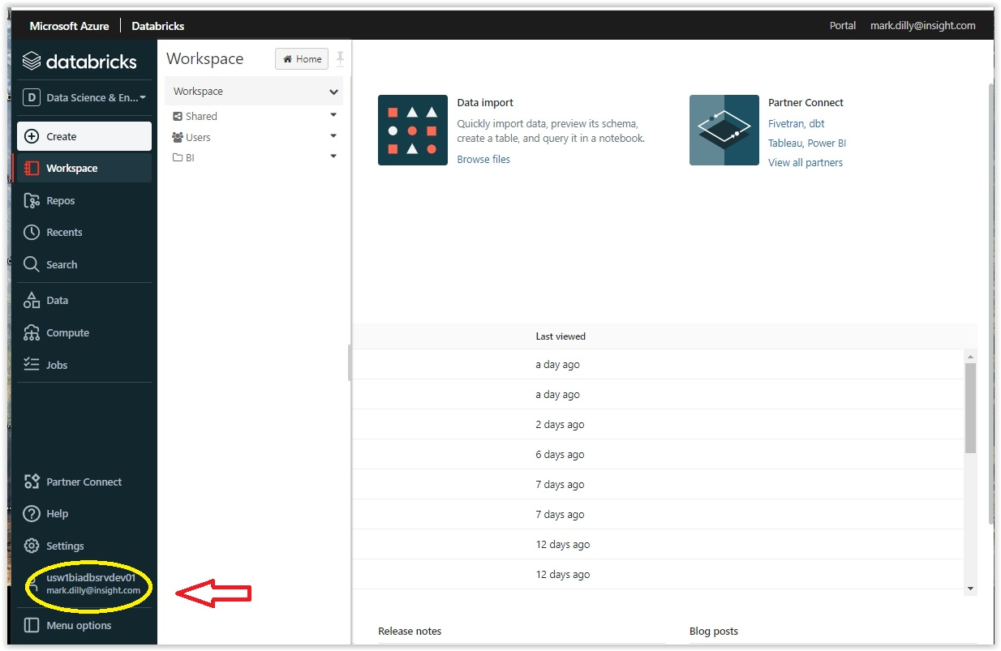

***Repos*** is where we store our source code. You copy your source code that is ready to merge into your personal Repo first, then request that it be merged into the “dev” repo. Once tested and verified it is moved into the “main” repo where it can be branched, merged, etc…

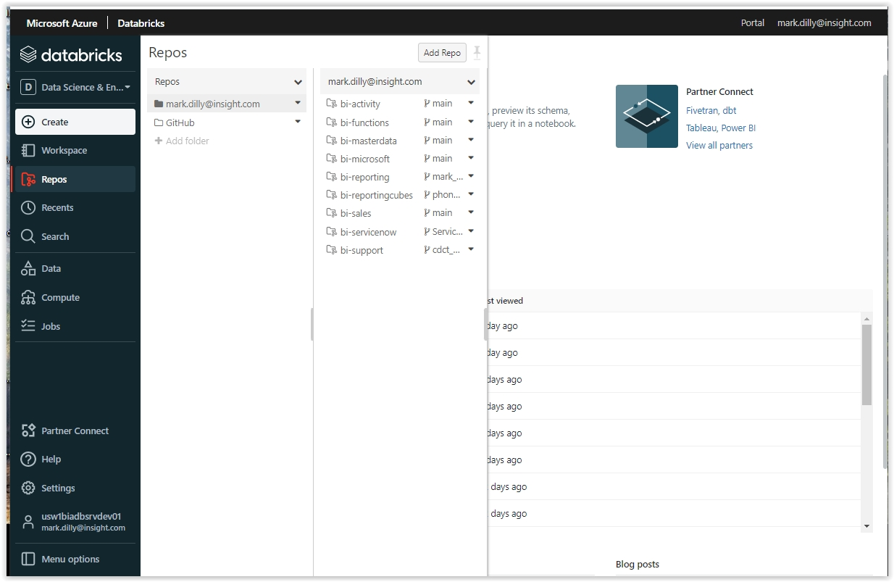

Main ***Repos*** contains all the repo folders for the databases (one-to-one):

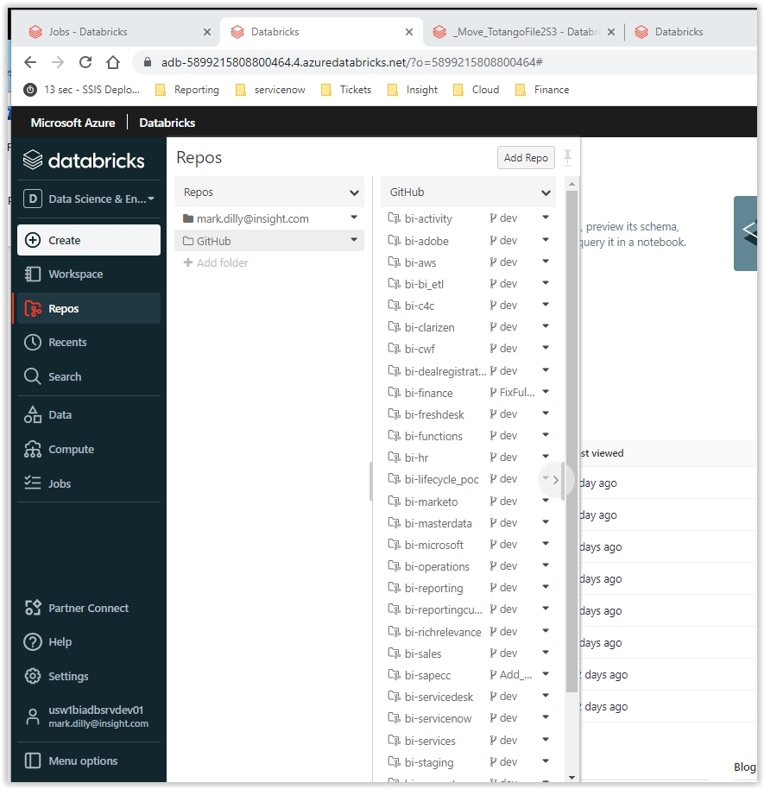

***Data*** will allow you to view databases, table structures, and data that you are authorized to see:

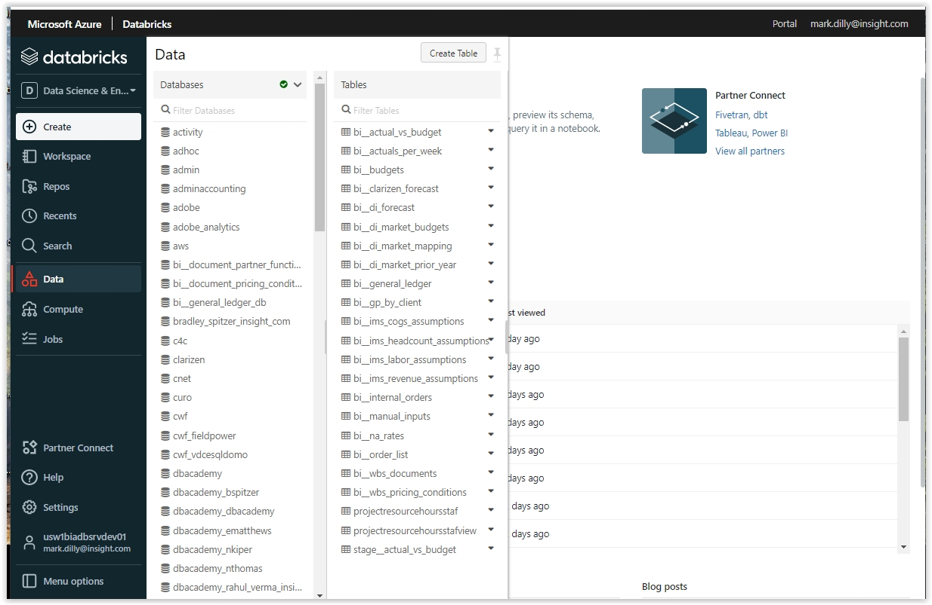

***Compute*** shows your computing and cluster options, typically we use the DataEngineering-HighConcurrency for development:

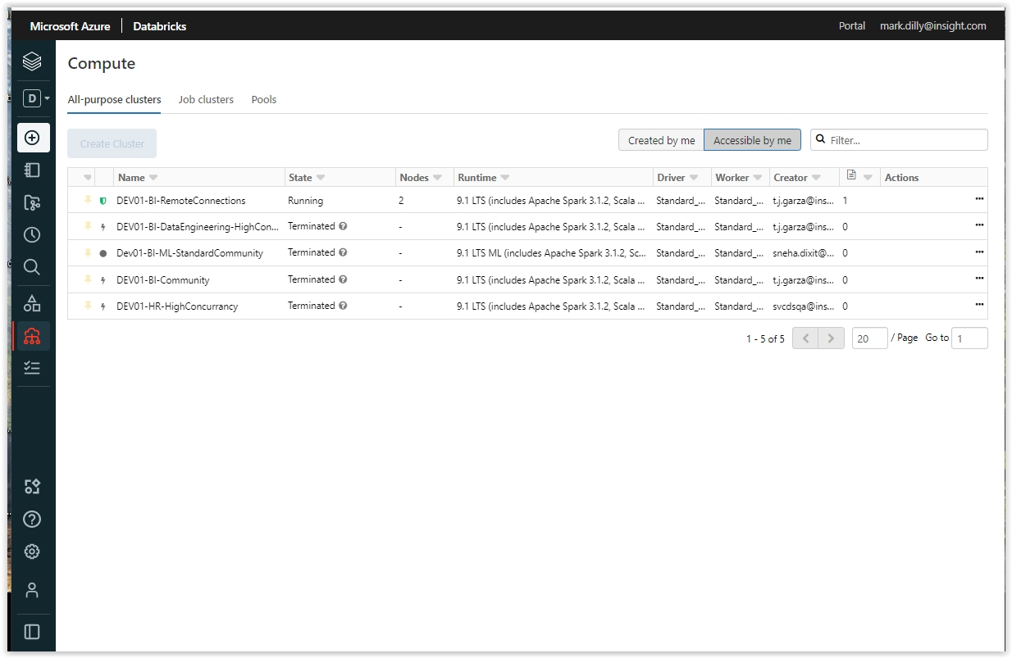

***Jobs*** allows you view/create access to jobs and scheduling:

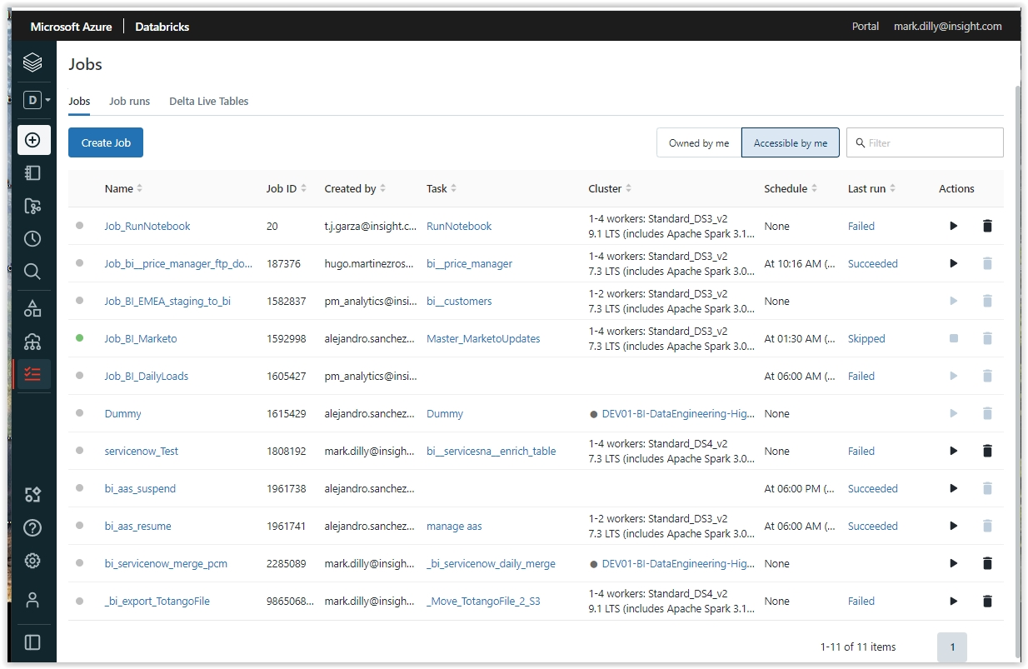

### Databricks SQL Interface [Josiah Melcher]

Databricks has recently added the SQL module for consumption by end users and data analysts.

Databricks SQL provides a simple experience for SQL users who want to run quick ad-hoc queries on their data lake, create multiple visualization types to explore query results from different perspectives, and build and share dashboards. This guide provides getting-started, how-to, and reference information for Databricks SQL users and administrators.

Reference doc: <https://docs.databricks.com/sql/index.html>

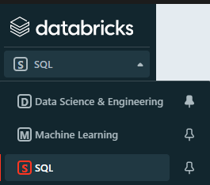

Users can access data from the delta tables and create parameterized SQL queries and dashboards. They can also export available data in a variety of formats (export using csv for large datasets).

The queries and dashboards can be shared with users if they are added to a Databricks Group (potentially will change once Azure ASD is integrated). Once an end user is given access to a group, (EX: DatabricksSQL-DashboardUserGroup) the dashboard or query can be shared with them using the owner’s (of the dashboard) credentials.

Databricks SQL is powered by SQL warehouses (once called SQL end points) a user group will need access to a SQL Warehouse to run queries and refresh dashboards.

### Microsoft Azure Storage Explorer [Sanjay Tanneeru]

Azure Data Lake (Blob) Storage

The environment makes use of Azure data lake (blob) storage as a flexible way to store various types of data including excel, csv, and other formats. Azure Blob storage is a service for storing large amounts of unstructured object data, such as text or binary data.

Typically used under the communityDL in the blob containers on each server instance (DEV, FQ, and PROD). Folders are created in this location for import and export data for various purposes.

*Setup and download software* -

* 1. visit <https://azure.microsoft.com/en-us/features/storage-explorer/#overview> to download Azure storage explorer software based on your operating system and install on your computer

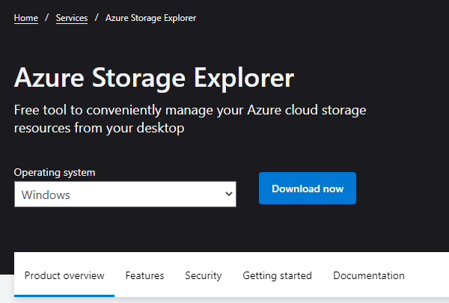

*Authenticate and get access* -

1) After installation follow the steps below to authenticate your account -

A) select user icon to “Add an account..”

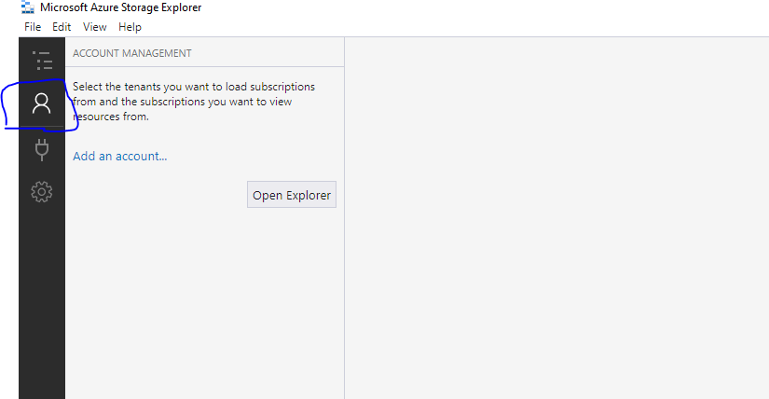

B) Select “Subscription”

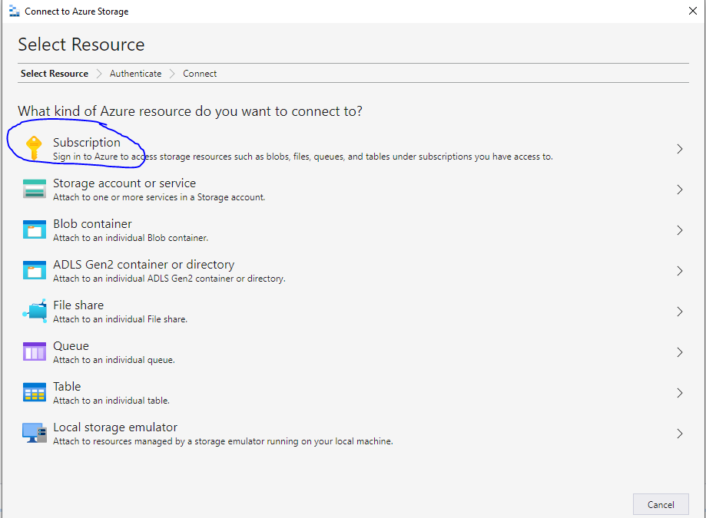

C) Select “Azure”

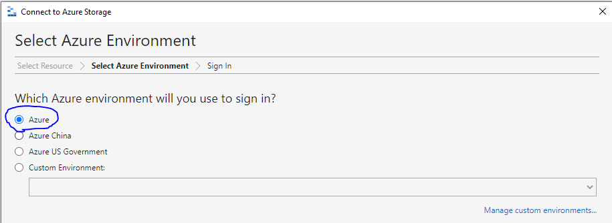

D) Opens “Sign In” screen in browser to login, select/enter your username and password and it gives you a message “Authenticated. You can return to Storage Explorer. You might need to authenticate again if you close this browser tab.” Once you go back to Storage explorer interface, you will see below screenshots

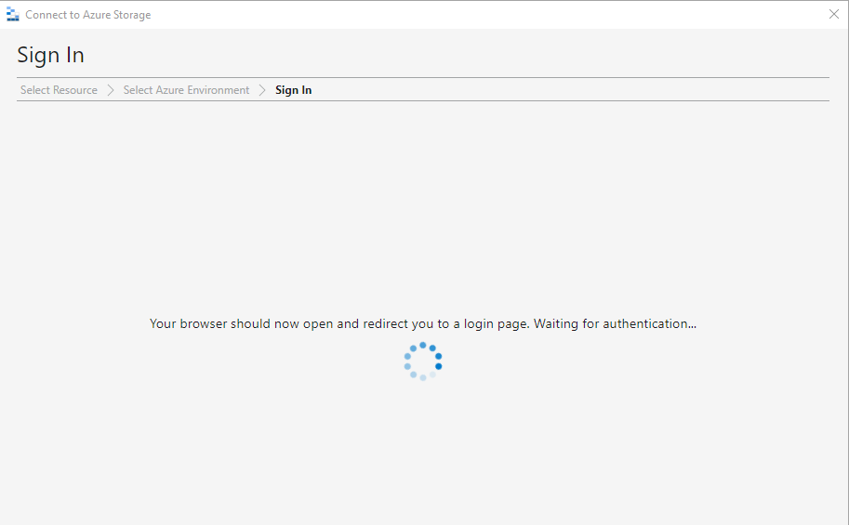

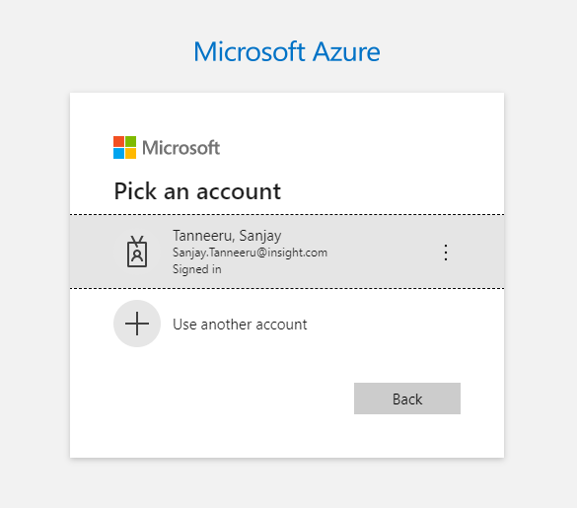

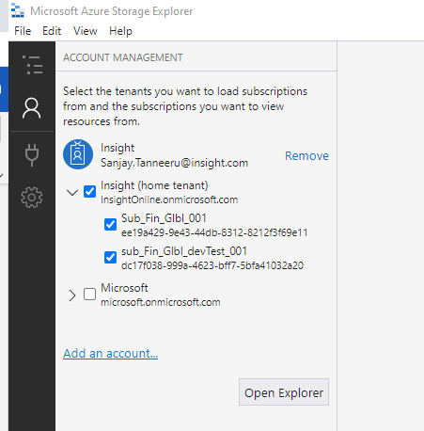

E) Go to Explorer tab to expand and see all storage accounts for Dev, FQ and production

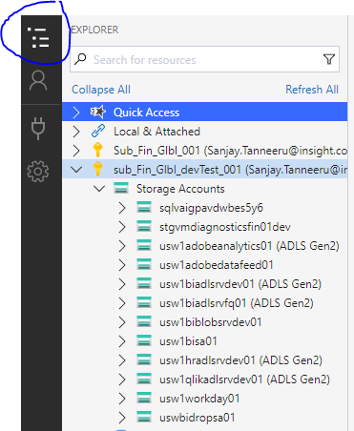

Dev and FQ locations:

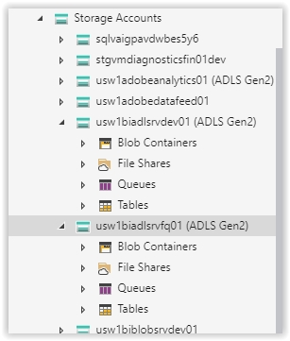

Production Location:

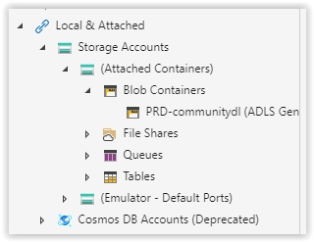

### Github [Evan Matthews]

Github provides Internet hosting for software development and version control using Git. It offers the distributed version control and source code management functionality of Git, plus its own features

Github is used as the distribution method of completed code. Code is built and tested in the development environment, branches created and merged to dev, pulled and deployed to FQ for testing, and pulled and deployed to PRD for live operations.

Each pull is reviewed and approved by designated developers thru the Git interface

Deployment of each pull is a separate step executed by a designated developer. This includes executing notebooks (i.e. creating tables, running notebooks that populate tables), updating permissions, job creation/scheduling, etc... so that the structures in the pull become operable.

#### Submitting a change to Version Control

Summary of Steps

* + Clone the repository into your personal repository (repo)
  + Perform the changes in Dev and verify the desired result, place them in your repository
  + Submit a new branch and commit request
  + Create a Pull Request to move your repository to the dev repository
  + Change Approval
  + Migration to production environment

#### Cloning Repositories Using Databricks Repos

After being granted access to the GitHub organization described in the introduction section of this document perform the following steps to integrate GitHub with Databricks and clone repositories.

1. Create a personal access token in GitHub by following the instructions [here](https://docs.github.com/en/authentication/keeping-your-account-and-data-secure/creating-a-personal-access-token)
2. Once you have created the personal access token
3. Navigate to the Databricks workspace
4. On the left pane, select settings à “User Settings”

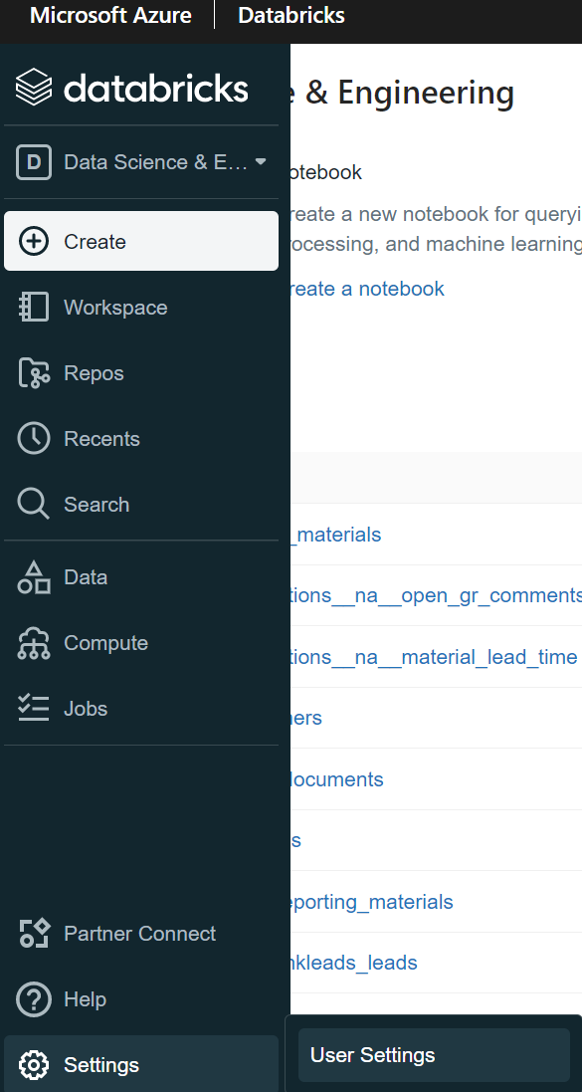

1. Select “Git Integration”

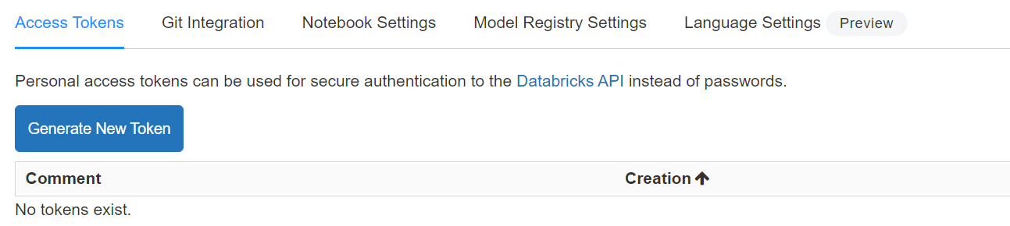

1. Select GitHub in the Git provider dropdown

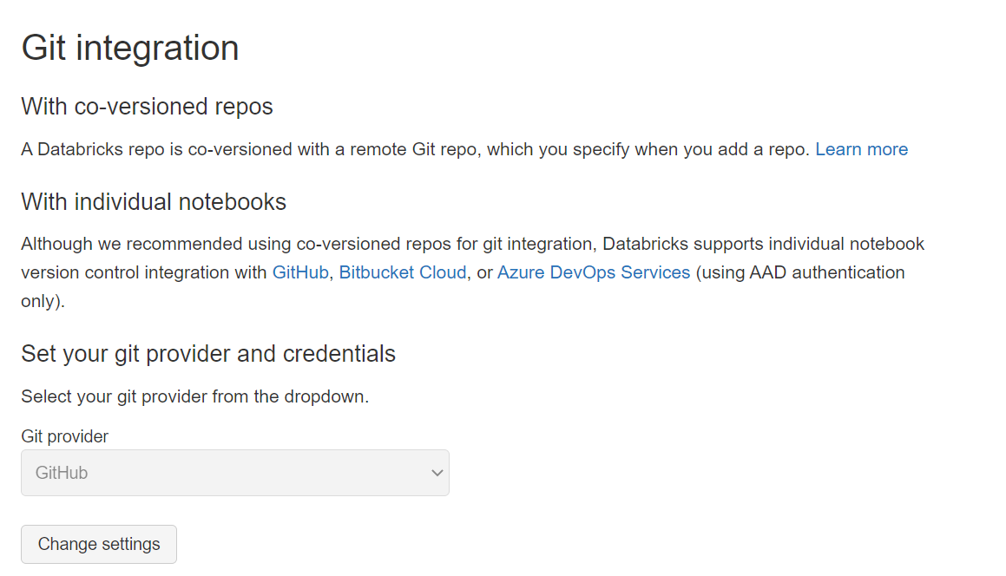

1. Enter your username and token

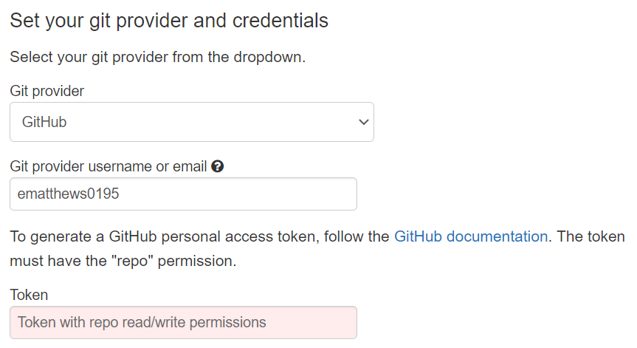

1. Save
2. After you have finished the Git integration process, perform the following steps to clone repos into Databricks.
3. Select the “Repos” option in the left pane

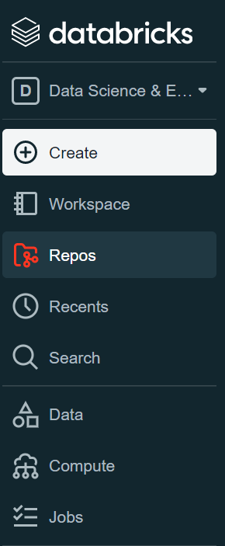

1. When you select the “Repos” option, you will see a “GitHub” folder as well as any user directory that you have been given permissions to. In most cases you will only see your own folder.

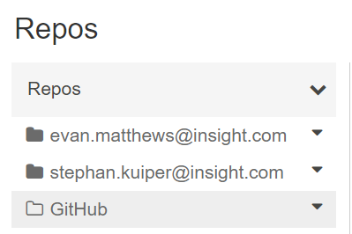

1. Select your personal directory (when setting up for the first time the following will open)

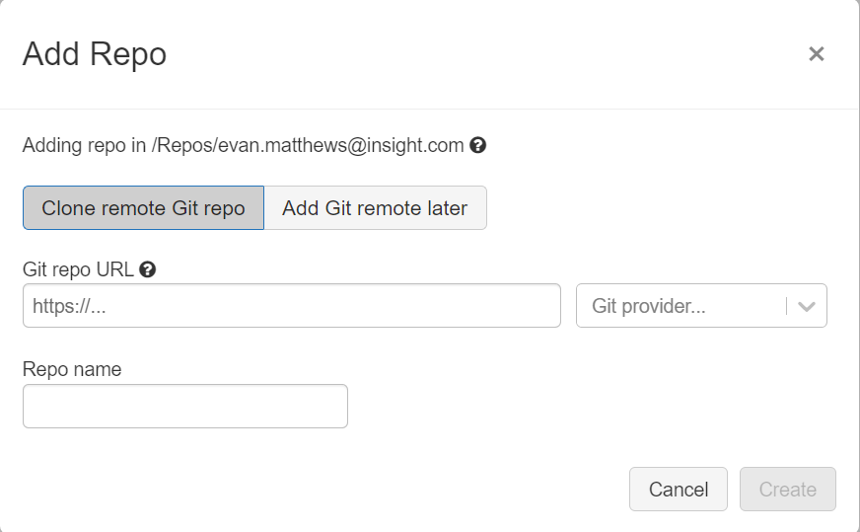

1. From GitHub navigate to the repository in which you are planning to perform new work, or make updates to existing work

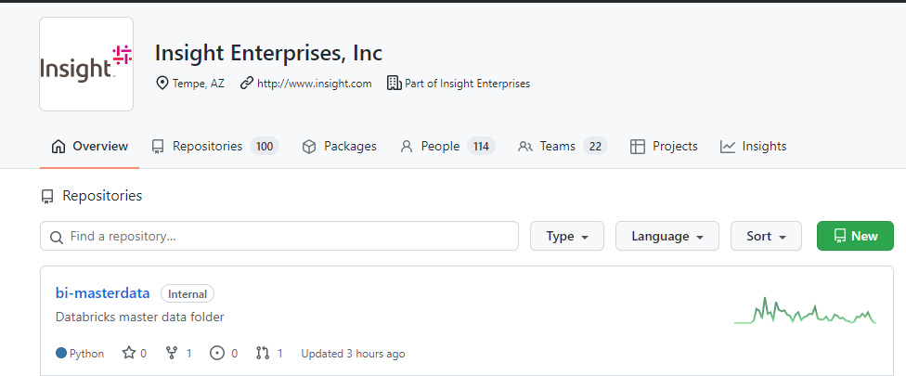

1. Once in the repository, copy the URL as shown



1. Paste the URL in the “Git repo URL” section of the form shown above

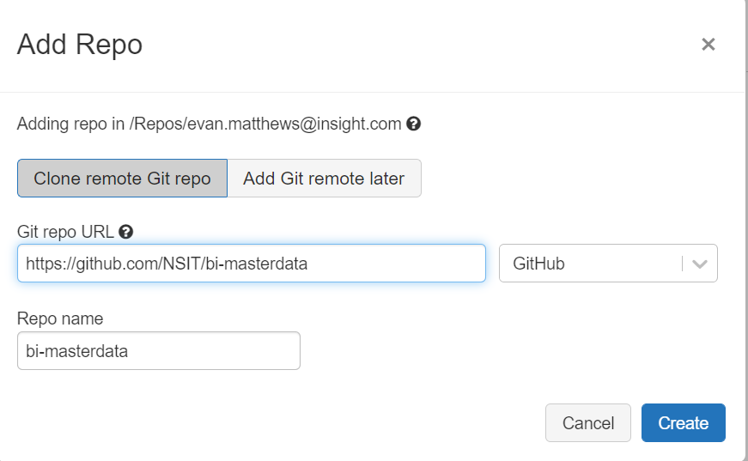

1. Select Create
2. The repo should be displayed in your personal directory and will show as follows

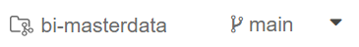

1. Assuming that the current workspace is the Databricks DEV workspace, the branch shown right of the repo name must be changed. To do so, perform the following steps
2. Select the branch button



1. In the window that displays, select the branch drop down

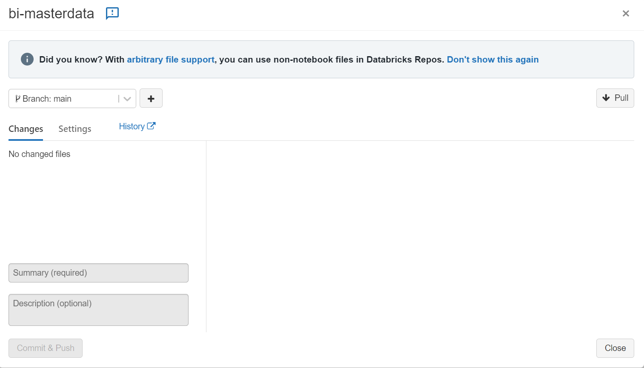

1. Scroll down and select “dev”

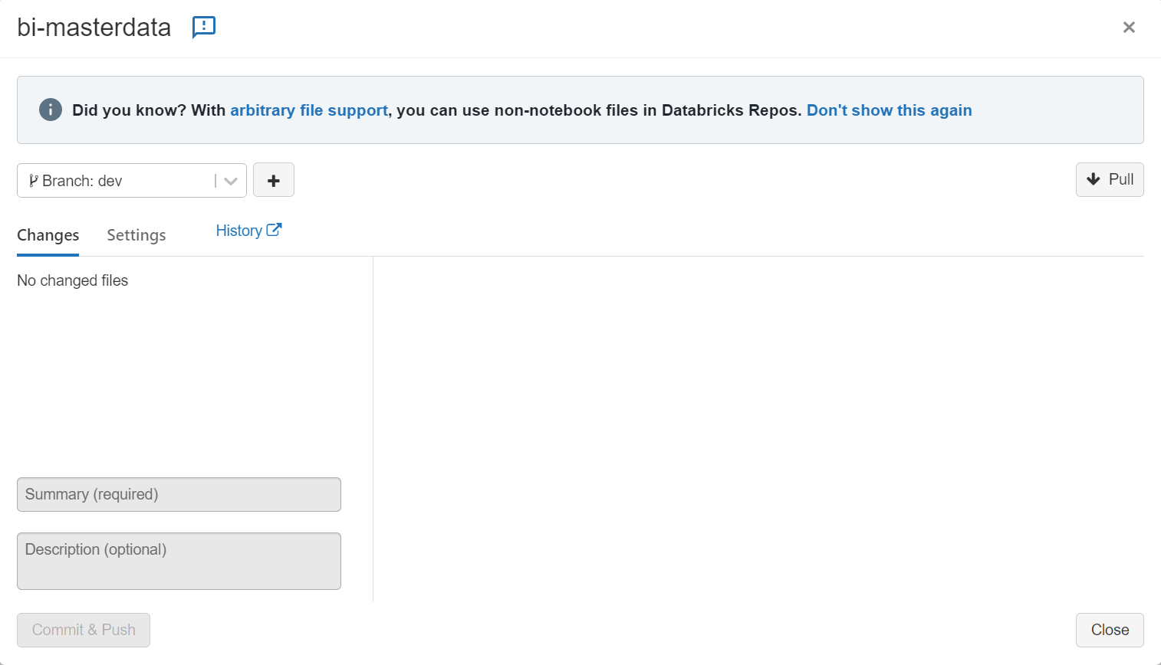

1. Select “Pull”
2. All notebooks currently in the dev environment should now be available under the folder.
3. Follow steps A - I for all repositories that you will be making changes to

Branching

The GitHub repository contains 3 standard branches described as follows

1. Dev – the dev branch contains all notebooks related to the development environment. All notebooks under the GitHub folder in the Databricks “Repos” section will point to the dev branch.
2. QA – the QA branch contains all notebooks related to the QA environment. All notebooks merged into the dev branch via pull requests will be migrated to the QA branch as part of the CI/CD process.
3. Main – the main branch serves as the source for all notebooks related to the production environment.

#### Creating Branches

Any time that a notebook must be created or modified, a branch should be created to perform the work. Branches should be created using the latest notebooks pulled from the “dev” branch.

Branches should be named in the following suggested format

***{first initial}{last name}-{dataset name}-{short description}***

*ematthews-renewals-fix-missing-records*

#### Committing Changes

Once a notebook has been modified, the changes made must be committed to the repo before being considered for merging. Perform the following steps to commit changes to a notebook using the Databricks repos feature.

1. With the notebook open, at the top left corner next to the notebook name the current working branch will be shown. Click on the current working branch



1. The following window will be displayed which will show all changes made to the given notebook under the current working branch

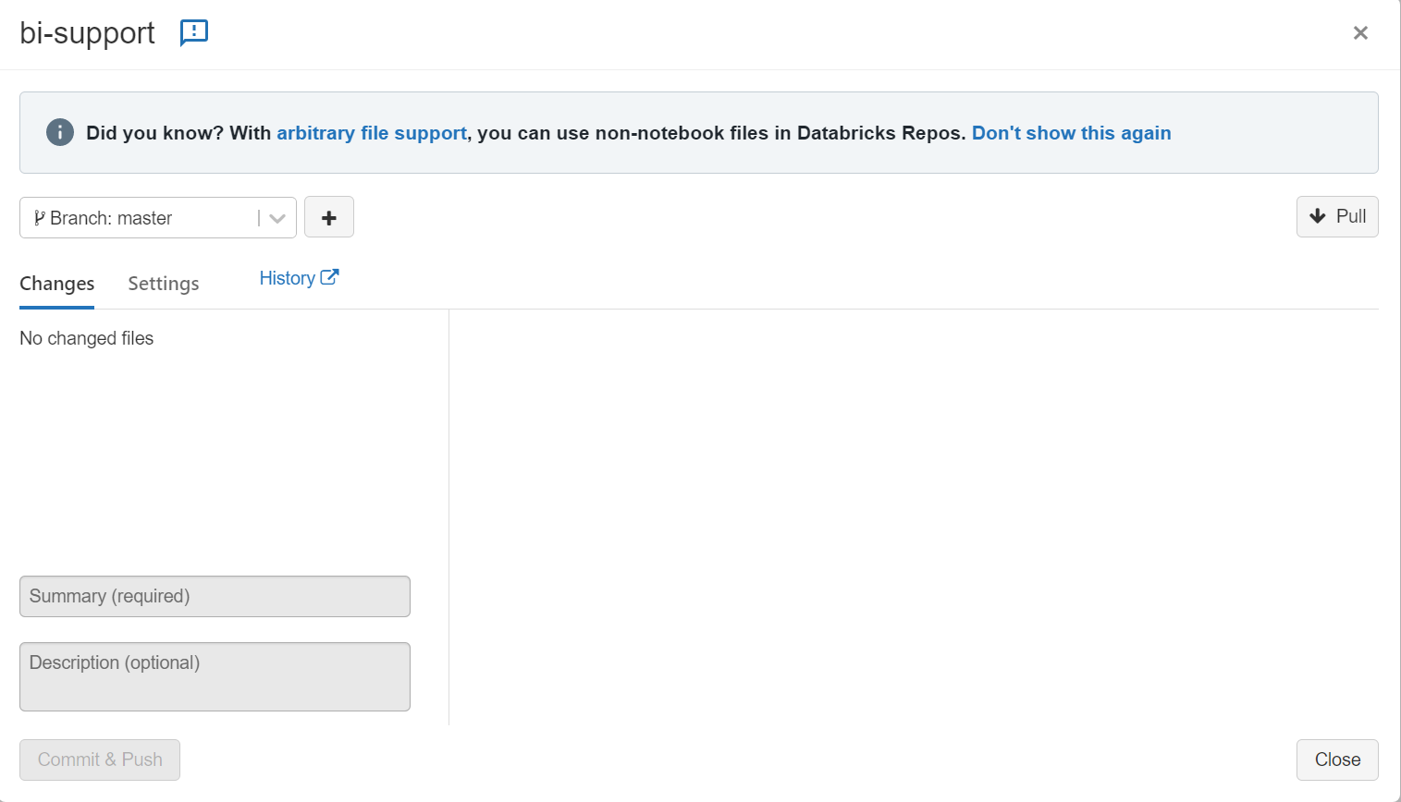

1. Add the summary of the work completed in the “Summary” field
2. Add a more detailed description of the changes in the “Description” field.
3. Once a summary and description have been added, select the “Commit & Push” button at the bottom left corner of the window



1. All changes that were made to the given notebook have been committed to the repo. To merge the changes made into the working DEV, QA, or PROD environments, a pull request must be created and approved by the change approval board (CAB). This process can be found in the next section.

#### Creating Pull Requests

After changes have been committed from Databricks, the following steps should be followed to create a pull request.

1. Navigate to the NSIT-Insight Enterprises, Inc. GitHub organization
2. Navigate to the repository in which changes were made
3. Upon opening the repository, a button will appear which will allow you to create a pull request for the changes
4. Fill out all the fields required to create the pull request
5. **Ensure that the pull request is being merged into the “dev” branch**
6. Create the pull request

**NOTE:** during the process of creating a pull request, you will see that a reviewer for the pull request is required. You do not need to manually specify who should review the pull request. Once a pull request has been created, if no approver has been assigned, the BI team will still review and approve the changes.

#### Change Approval

Once a pull request has been created for any changes made to notebooks in the Databricks workspace, the changes must be reviewed and approved by the BI team. The team reviews requests on Friday, Monday, and Tuesday mornings to determine if they are fit for release.

All pull requests should be submitted before the end of the day on Monday to be considered for weekly deployment. Even if a pull request is submitted before the end of the day on Monday, it is not a guarantee that the pull request will be approved in the Tuesday review. This means that in some cases, if the BI team is unable to review and approve a given pull request on Tuesday, the changes will need to be approved in one of the following review sessions and wait until the following weeks deployment.

#### Migration

Once a pull request has been reviewed and deemed fit for approval, the changes will then be merged into the DEV environment. On the same day that changes are merged into DEV, they will be migrated to the QA environment for testing before PROD migration.

Production migration happens once a week on Thursday. On the Wednesday preceding the scheduled deployment, the changes in QA will be checked to ensure that they have been tested. Upon confirmation of QA successful testing, Thursday morning the BI team will notify the change approval board (CAB) that changes are being made in production. Thursday evening, all pull requests that have been approved on either Friday (of the previous week), Monday, or Tuesday will be deployed to production.

# Access to Tools [Evan Matthews]

To perform any work in the Databricks workspace two sets of access are required. Firstly, access needs to be granted to the appropriate Databricks workspace. Secondly, the user should have a GitHub account and be granted access to the appropriate organization and role.

## Databricks Workspace

To get access to the appropriate Databricks workspaces, a service desk ticket will need to be created. When creating the ticket, the request area should be set to “Insight.Reporting.BI & Reporting.Databricks Access”.

This request area can be selected in two ways

1. Type in the “Request Area” text field to search for the area

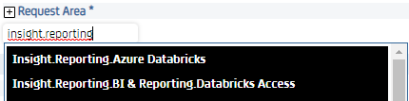

1. Select the area by clicking on the “Request Area” text and navigate to the area in the window displayed

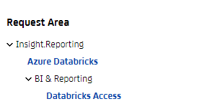

1. After selecting the “Databricks Access” request area, the following should be displayed at the bottom of the request screen

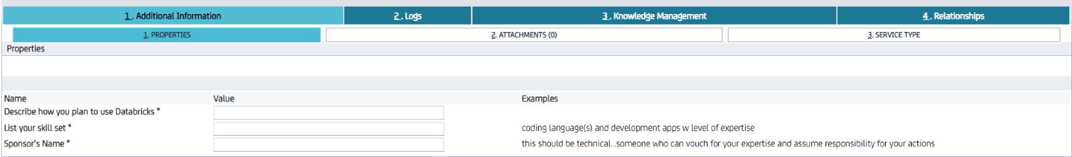

1. Fill out the fields and submit the request. These answers will be used to review the request and determine if access should be granted

Once the ticket has been completed and approved, you should be able to access the Databricks workspace.

## GitHub

All code is version controlled via Git integration using GitHub and the Databricks Repos feature. Before any code can be submitted for review and added to the MDA, you must first be added to the appropriate GitHub organization. To be granted access to the GitHub organization perform the following steps.

1. Create a GitHub account (a free account will work)
2. Contact the BI team and provide your GitHub username
3. The BI team will communicate that access has been granted for the username

# Naming conventions

## Database naming [Mark Dilly]

Databases should be named in lower case and reflect the source and/or type of data to be stored there.

You may use single underscores to separate words, but should be kept short (under 30 characters). i.e. “masterdata_ecc” indicates what it is and where its coming from.

Upper case letters are not used in database naming conventions as Databricks removes the case when it is created.

* SAPECC à sapecc
* Microsoft à microsoft

“reporting” is a global database similar to our previous marketing_work. We put very specific structures/tables/views for reporting and groups here. The structures within should have names reflecting the company group i.e. finance__ap_hm_gv, marketinghold__holds, ukfrmwrk__monthlyspend, etc..

“sales” would typically contain structures/data related to dynamic sales data including: billing and sales documents, product serial numbers, bookings, backlog, invoices, sales pipeline, renewals

“masterdata” contains those structures containing fairly static data like, customers, employees, holidays, manufacturers, materials, and sales organizations/offices/categories

## Github Repo naming [Sanjay Tanneeru]

For all BI objects, the convention being followed is “bi-<name of the objects>” example – “bi-microsoft" or “bi-sales” in lower case with hyphen separated.

For non-bi related repos which could be projects/initiatives of their own, we want to keep the description as short as possible with no special characters (details to the determined as we come across more use cases)

When creating a new repo, if a database already exists, we want the name of the repo to reflect the database name

Example – if a database called “microsoft” exists in databricks then we would create a repo in Github called “bi-microsoft”, benefits include being able to search the repo based on database name although there could be some exceptions

List of available repos to view - <https://github.com/orgs/NSIT/teams/businessintelligence/repositories>

## Databricks Job naming [Josiah Melcher]

Jobs should have the following naming convention:

* + Prefix: job_bi_ (ex job_bi_marketo)
  + All lower case
  + Underscore word separation (ex job_bi_general_ledger)

## Databricks Table and View naming [Mark Dilly]

To avoid possible duplication or conflicts, table names should be lowercase, as some areas of databricks ignore case and others dont. We have reserved “__” double underscores as a separator. See the conventions below:

**[raw,bi, vw]__[instance]__[tablename]** – not all tables/views have instances, if not, replace “__[instance]__” with “__”. i.e. “raw__workspace” vs “raw__na__workspace”

**[raw,bi]** - “raw” for tables copied down from another source, “bi” for tables that are enriched from data coming from raw tables, “vw” for sql views based on other tables or a query.

[instance] – this can be one of several variations. “na” - North America, “uk” – United Kingdom. The servicenow database has 3 instances, one for datalink, servicesca, and servicesna.

[tablename] – name of the table or view in lower case

## Table and file locations

### Physical table location [Mark Dilly]

Table storage locations are tied closely to the table naming conventions. This makes **following the table naming conventions critical** for file storage locations.

Files containing table data are stored in the [bidl container] along with the database name as a subfolder: abfss://bidl@usw1biadlsrvprd01.dfs.core.windows.net/servicenow

Lower level folders are split out by the database and table names. The “__” separators in the table name determine the folder location.

A table in database ”servicenow” named “bi__datalink__choice” is split out to the folder/file:

[bidl container]/bi/datalink/choice

The full location would be:

abfss://bidl@usw1biadlsrvprd01.dfs.core.windows.net/servicenow/bi/datalink/choice

If the dataset being created is a global dataset, then partitioning of the source company and ERP must be used. This ensures that global data from various processes can be written to the same folder directory concurrently without running into write issues.

### Creates [Evan Matthews]

The “creates” folder is where table creation notebooks are located.

A create notebook should be used to instantiate the table which will be used to contain the new dataset. The notebook will also be used to specify all the column names which will be present in the final BI enhanced table. Each column will be followed by a comment which describes where the field originated from, or how the field has been calculated.

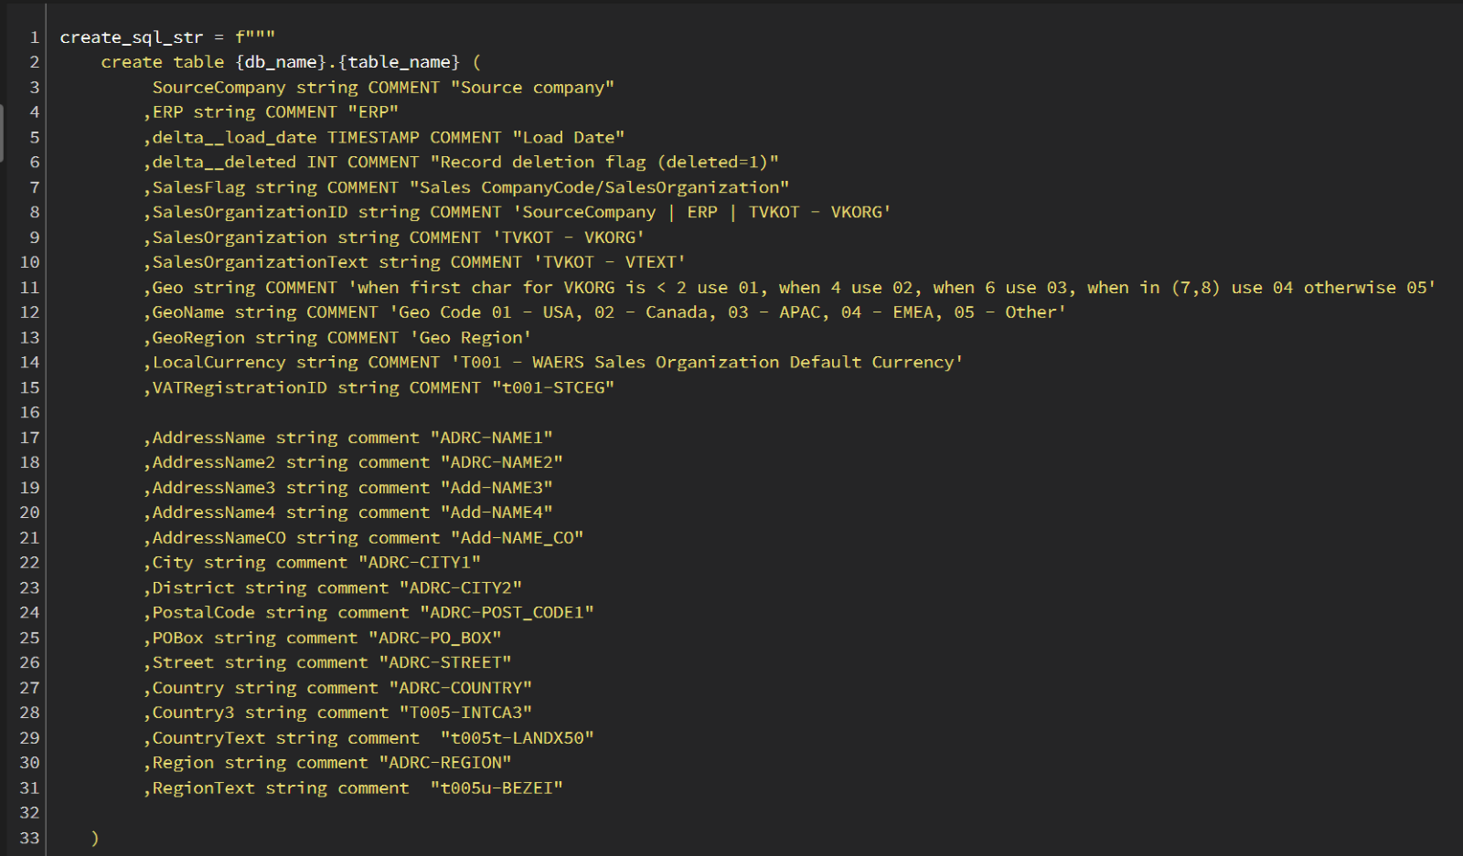

If the dataset being created is a global dataset, then partitioning of the source company and ERP must be used. This ensures that global data from various processes can be written to the same folder directory concurrently without running into write issues.

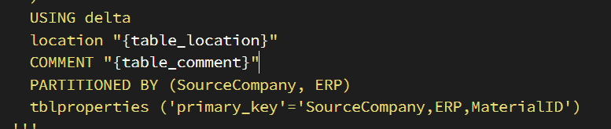

The “tblproperties” specifier should be added to all tables being created. This describes the primary keys of the table and ensures that if any configuration tables reference the BI table, they are able to determine the keys which should be used for delta ingestion.

The “create” notebooks must also support deletion and removal of previous objects with the same name to allow table modifications and re-creation. This includes the database table and the underlying file the data is stored in.

Prior to a table create, there must be a “drop table” command file system “remove”

The following code snippet illustrates the steps taken to drop and create a table consistently

Code Snippet:

*db_name = 'servicenow'*

*table_name = 'bi__datalink__choice'*

*table_comment = 'enriched sys_choice'*

*import os*

*location = os.environ.get("ADLS").format(container="bidl",path=db_name)*

*table_location = f'{location}/{table_name.replace("__","/", 2).lower()}'*

*drop_sql_str = f"drop table if exists {db_name}.{table_name}"*

*spark.sql(drop_sql_str)*

*dbutils.fs.rm(table_location, True)*

*create_sql_str = f'''*

*CREATE TABLE {db_name}.{table_name}*

*(*

*delta__load_date timestamp*

*,sys_id string*

*…*

*)*

*USING delta*

*location "{table_location}"*

*COMMENT "enriched sys_choice"*

*'''*

*spark.sql(create_sql_str)*

### Updates [Aaron Kyler]

Notebooks for updating tables should be put into the Updates folder in the repository for the corresponding database. The notebook names should reflect the tables being updated. These notebooks should be designed to be executed on an appropriate frequency via our Databricks workflow. These notebooks should update the data in the specified table(s) via methods such as overwrite or merge based on delta date load/change fields as appropriate.

#### Pyspark Merge example

DeltaTable.forName(spark, target_table).alias("t") \

.merge(updateDF.alias("s"),join_columns) \

.whenMatchedUpdateAll() \

.whenNotMatchedInsertAll() \

.execute()

## Column naming [Josiah Melcher]

This does not necessarily apply to tables in raw form (copy of data from a source) as they should reflect the source system column names, or at least have the original column name in a comment.

Columns in bi__ tables should follow the below guidelines:

Names should have each word capitalized with no special Characters (" !"#$%&'()*+,-./:;<=>?@[\]^_`{|}~")

no abbreviations – If names are long, drop words. do not abbreviate

All letters in acronyms should be capitalized

Current Exceptions: Soldto, Billto, Shipto the Insight Dictionary declares these to be compound words

# Data

## Tables

Each table should include the following columns and be populated at loading:

delta__load_date – timestamp contains date/time the record was loaded

delta__deleted – integer flag that indicates soft deletion (delete = 1)

### Table creation

Table creation notebooks are located in a subfolder named “\creates” in the database folder hierarchy

### Table updates and population (deltas)

Table update/merge notebooks are located in a subfolder named “ \updates” in the database folder hierarchy

## External Data Sources [TBD]

This section contains an overview of the external sources of data loaded into Databricks. It is broken out by database where the incoming data resides. Individual items are identified along with the outside source. In some cases the method of acquisition is also described. For further detail go to the associated notebooks in the update folder in databricks.

### activity

This database contains raw tables pulled from the Cisco phone system which can be used to report on phone activity. The data is transferred by the IT Team.

### adobe

Data pull for the Adobe VIP Enrollment usage data from On-prem sql.

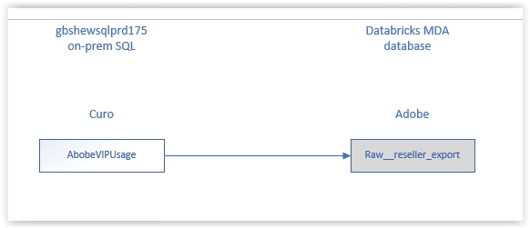

### freshdesk

Data is acquired via API calls and transported here by processes created by the IT team (Barney Horton)

### hr

Data is transferred from “My Teammate Central” (MTC) to this location by the IT group. The data is encrypted using python mechanisms and is strictly controlled.

### marketo

This is marketing data transferred by the IT Team

### sapecc

This is data transferred from the North American SAP system. It is transferred here by the IT team using cliq. structures and columns typically reflect the SAP naming conventions and are tables are named “raw__na__[TCode]” where Tcode identifies the SAP table where the data originates

### servicedesk

Data is transferred here from the Insight servicedesk system by the IT team (Barney Horton). This is a ticketing system used within Insight

### servicenow

servicenow is a ticketing system used by services teams throughout Insight. Data is sourced from 2 instances of servicenow. The data is acquired and updated daily using the servicenow REST API. It merges new and changed records into the raw tables

Global North America – servicesna

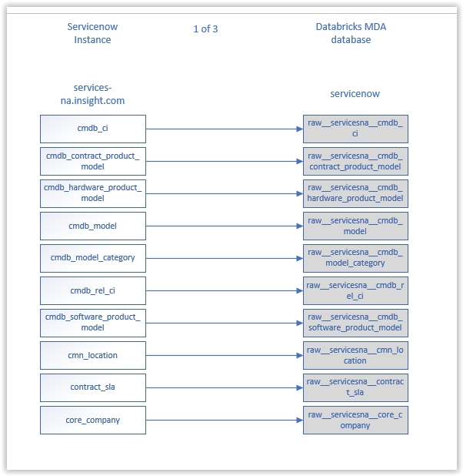

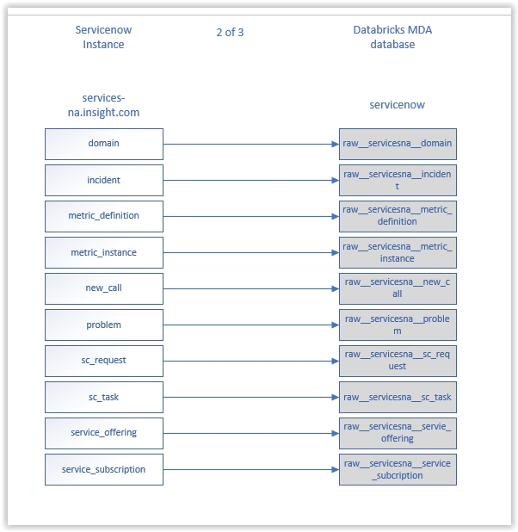

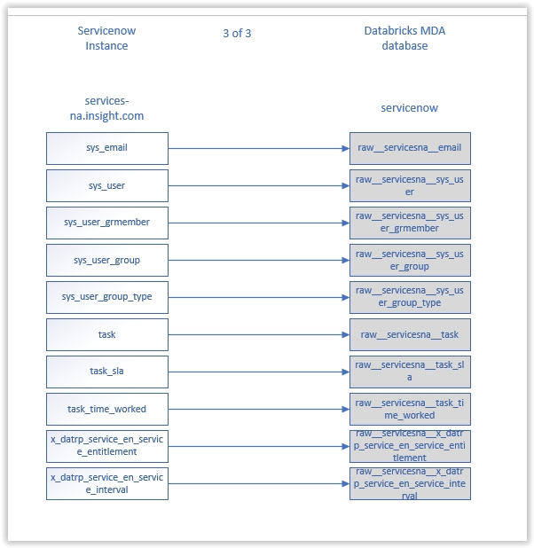

Canada – servicesca

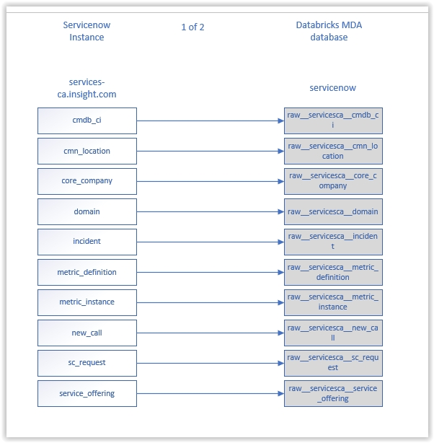

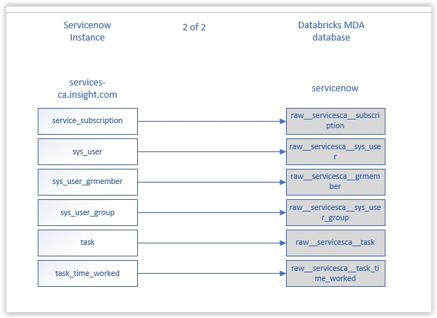

### TBD

## BI Databases and Datasets

Database names generally describe the contents within. They are usually named based on the data source. The bi_team does not own or maintain all of them, but those we own are documented below. Here are several examples:

masterdata – master data imported and enhanced from sapecc and other sources that is enhanced by the bi team, examples: bi__customers, bi__employees, bi__materials

sales – sales related data imported from sapecc and other sources that is enhanced by the BI team, examples: bi__billing_documents

NOTE: The diagrams listed below are an attempt to show the sources behind each table. In general the sources read from left to right, with the target at the right in a dark fill color. This gives some idea of the complexity of the dataset as well as where it comes from. For additional information see the corresponding notebook in creates/updates folders

The following databases are either populated by the Finance BI team or the tables are used as a source for bi populated datasets:

### Finance [Mark Dilly]

This database contains finance related data

#### bi__microsoft_incentive_detail

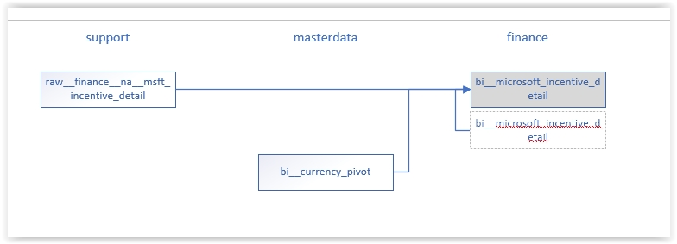

#### bi__sales_quota

This table is sourced from AX

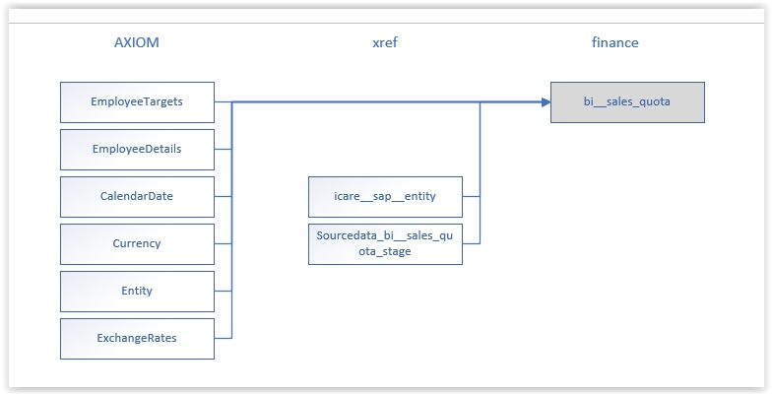

#### bi__account_payable

This file is sourced from SAP

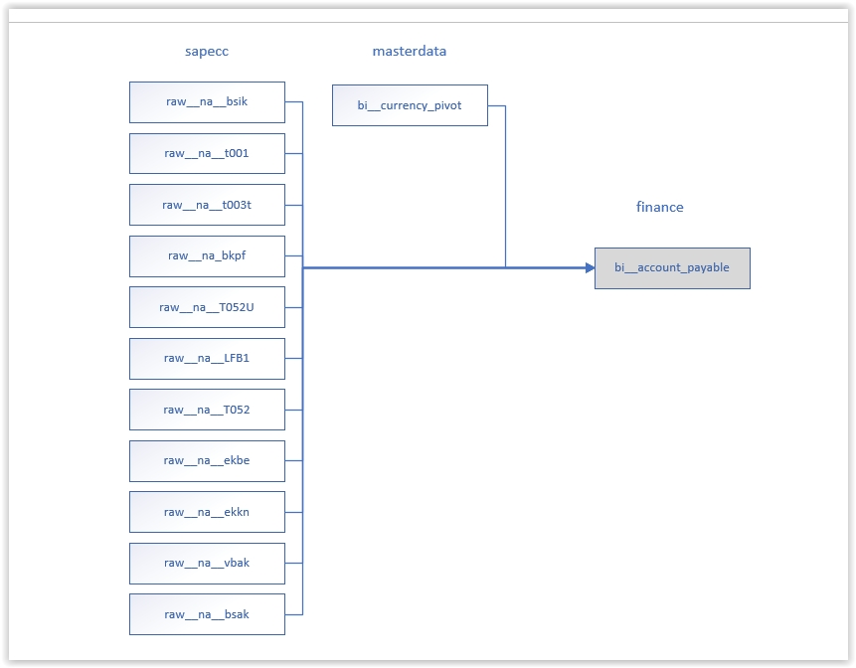

#### bi__account_receivable

This table is sourced from SAP

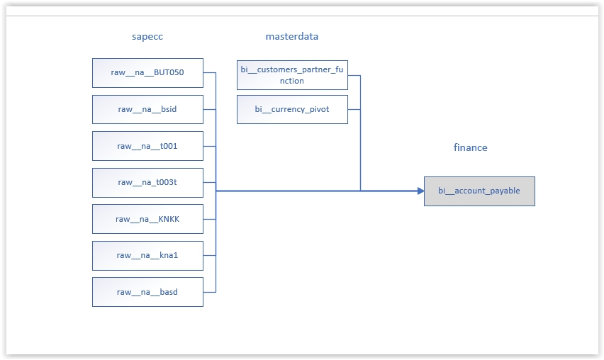

#### bi__ar_quarter_target

This table is sourced from SAP

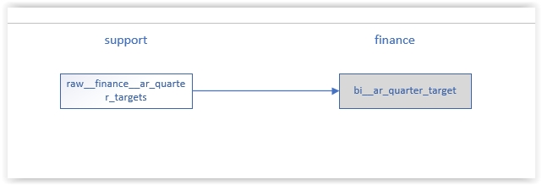

#### bi__arrears

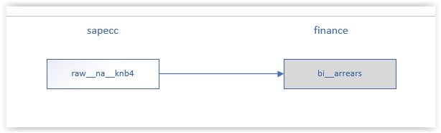

#### bi__budget_bookings

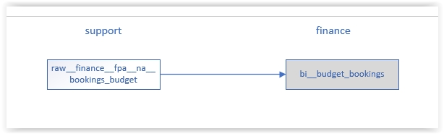

#### bi__budgets_by_pline_by_profit_center

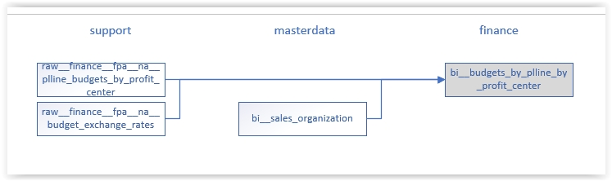

#### bi__commission_adjustments

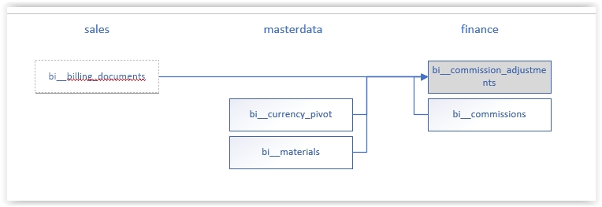

#### bi_commissions

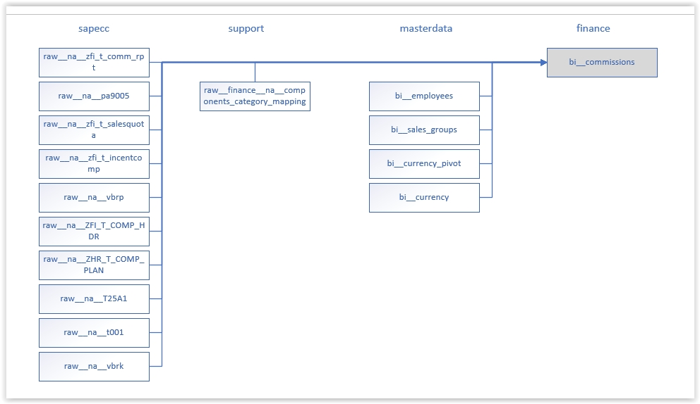

#### bi__commissions_attainment

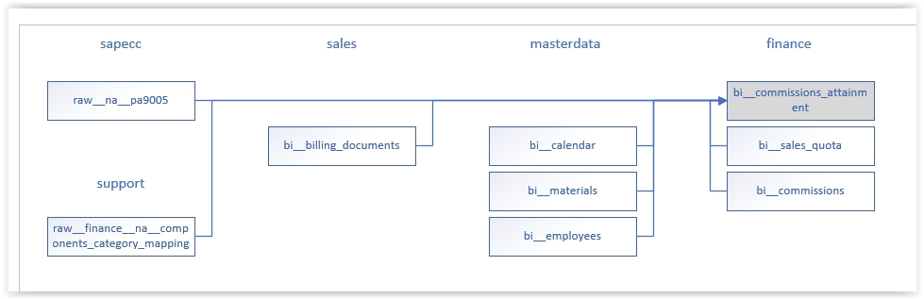

#### bi__commit

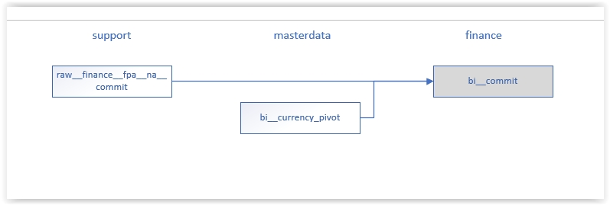

#### bi__credit_management

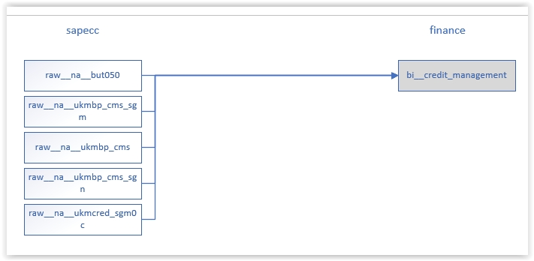

#### bi__creditreturns_rebills

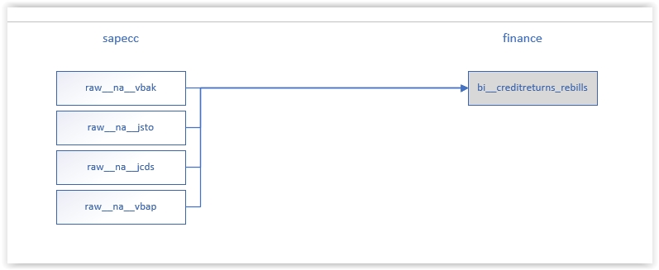

#### bi__customer_credit

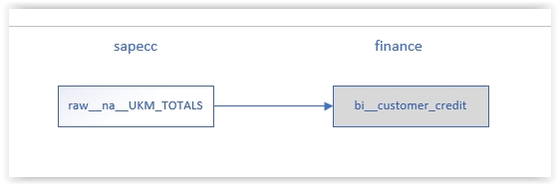

#### bi__customer_credit_management

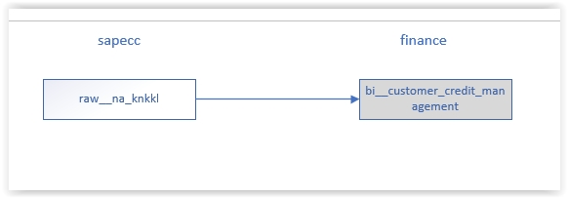

#### bi__daily_pricing_combined

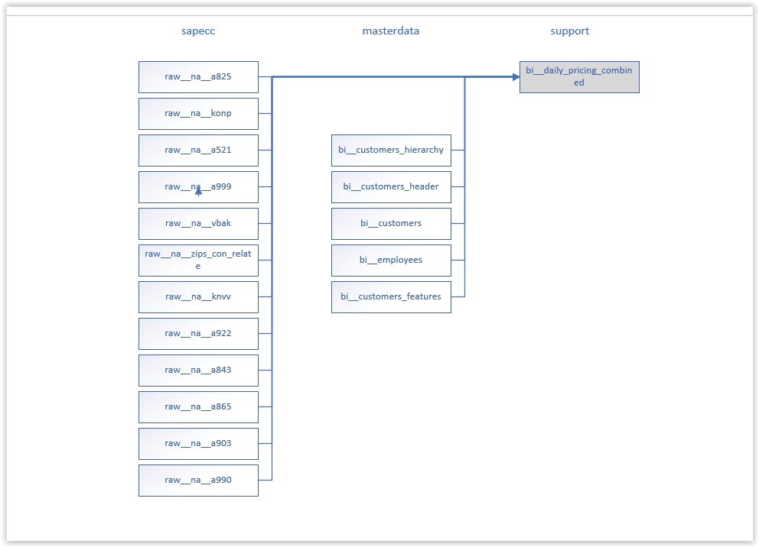

#### bi__dispute_management

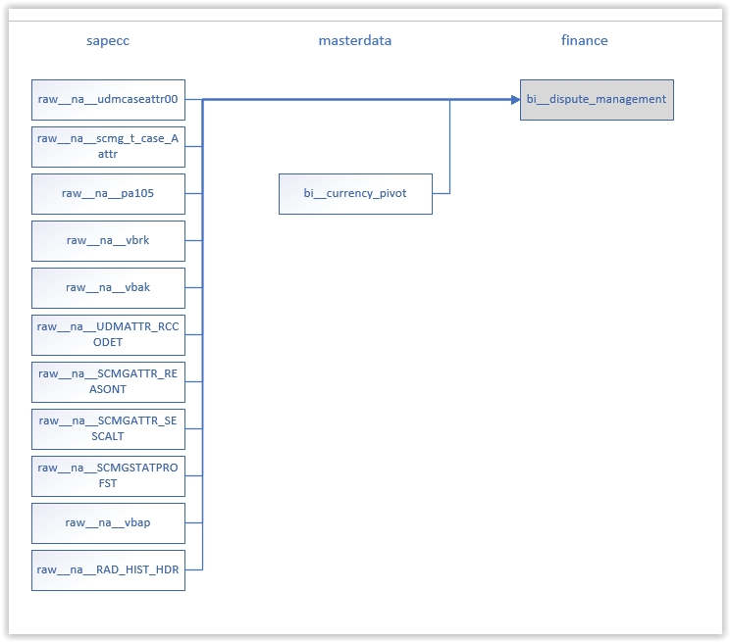

#### bi__stat

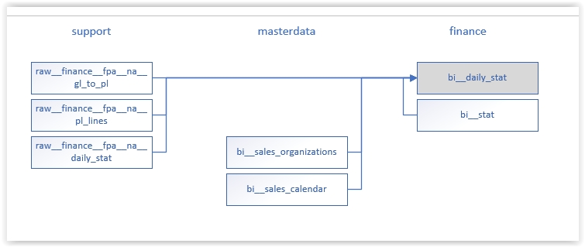

#### bi__t_and_e_budget

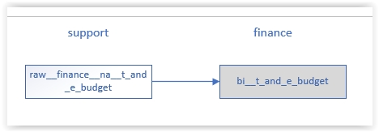

### Masterdata [Mark Dilly]

This database contains BI enhanced tables that are considered “master” tables of record, regularly updated from several sources of data including SAP raw tables.

The following diagrams outline the datasources and datasets used to populate the bi_ tables in masterdata

#### bi__active_directory

This table is sourced from AX

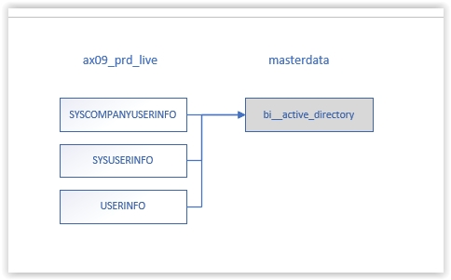

#### bi_calendar

This enhanced table is sourced from AX

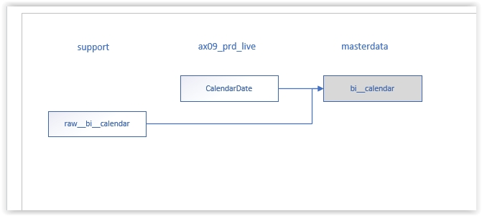

#### bi__categories

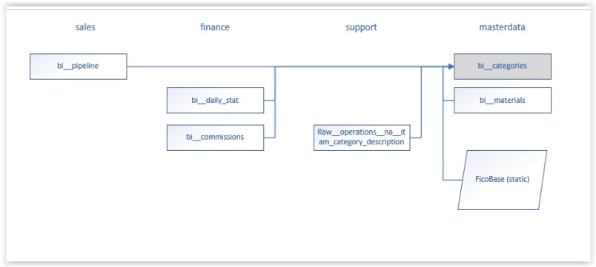

#### bi__cnet_manufacturer

This is an enhanced table sourced from CNET

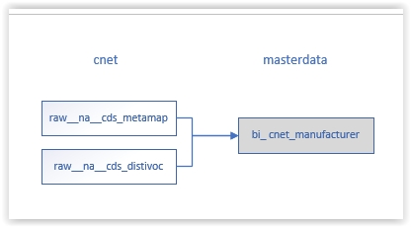

#### bi__cnet_product

This is an enhanced table source from CNET

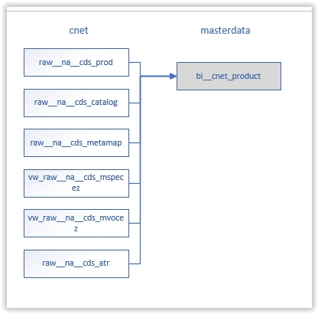

#### bi__cnet_unspsc

This is an enhanced table sourced from cnet

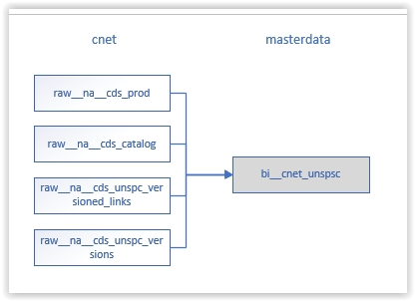

#### bi__currency

This enhanced table maintains currency conversions sourced from AX

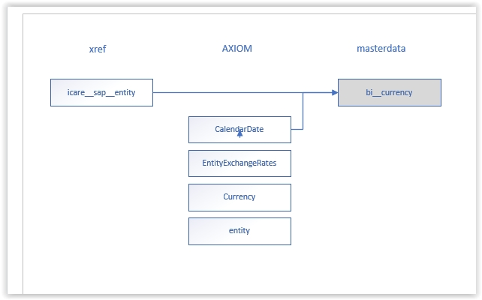

#### bi__customers

bi__customers is an enhanced dataset that ties master customer data together. It is sourced from Alliance, AX, SAP and PCM data.

Alliance

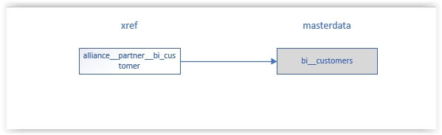

AX

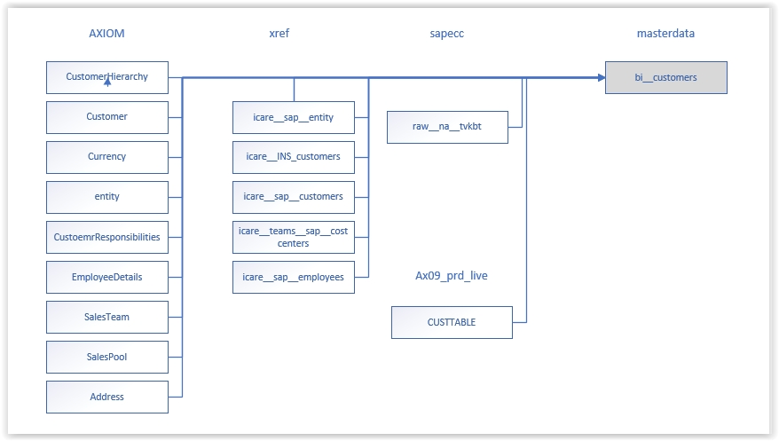

PCM

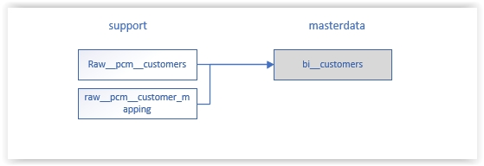

SAP

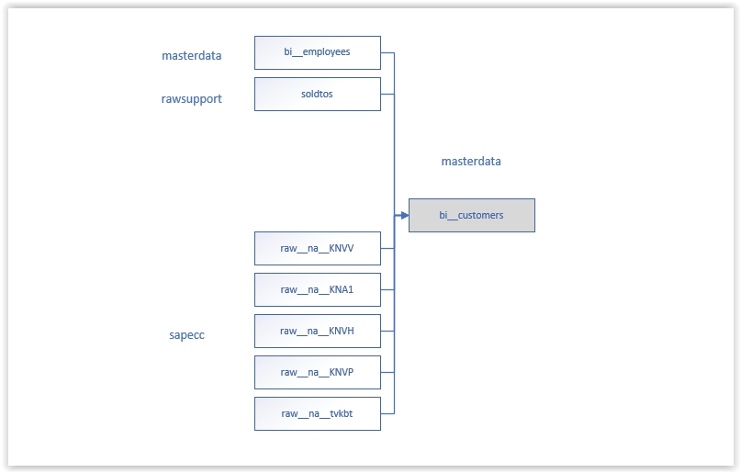

#### bi__customer_header

This table is sourced from AX

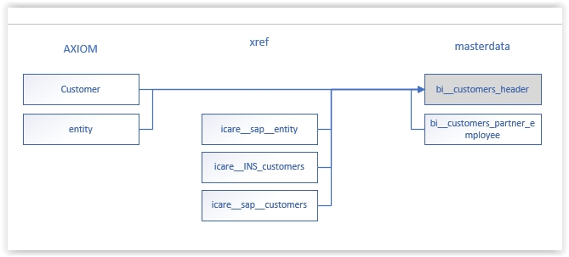

#### bi__customers_hierarchy

This enhanced table is sourced from AX

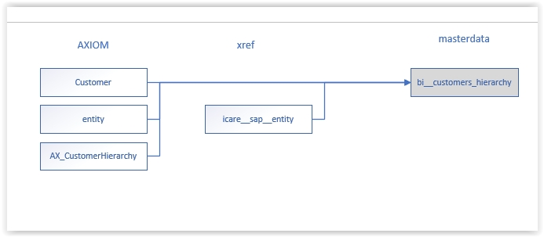

#### bi__customer_profile

SAP

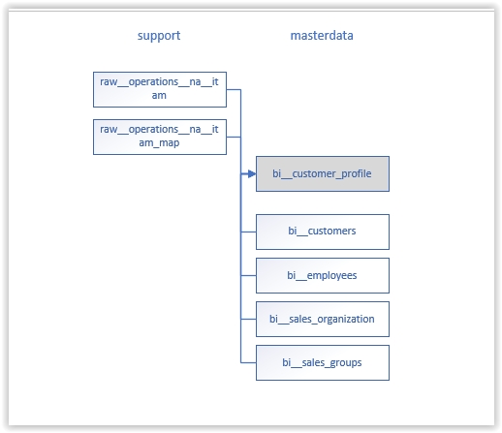

#### bi__customers_company_code

This enhanced table is sourced from AX and SAP

AX

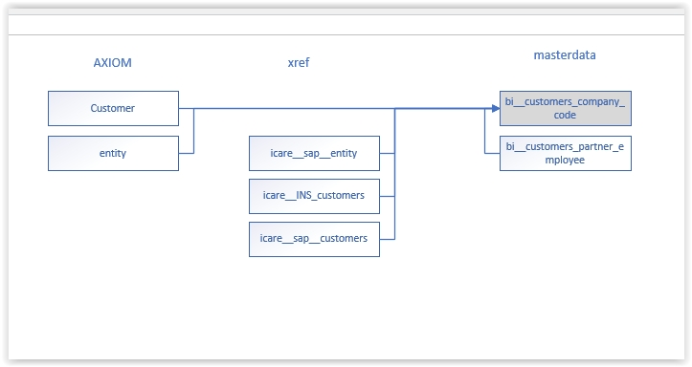

SAP

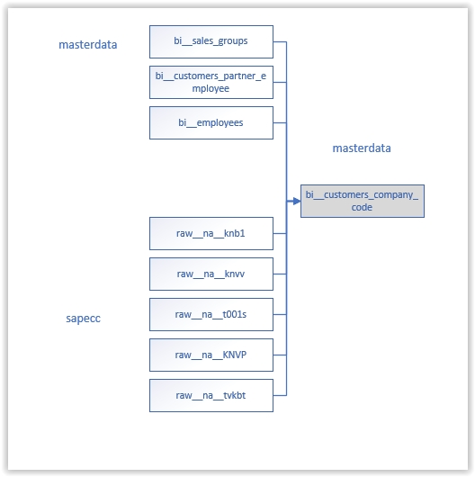

#### bi__customers_partner_employee

This table is sourced from AX

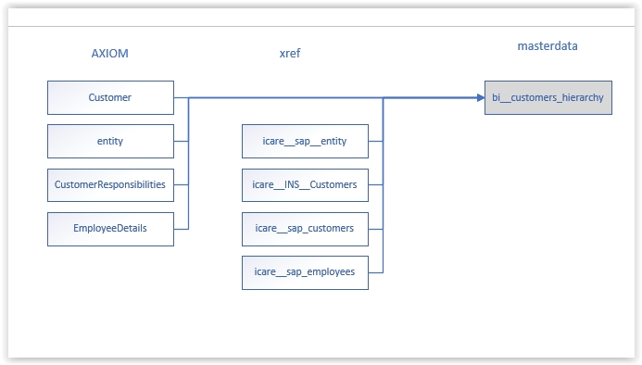

#### bi__customers_partner_function

This table is sourced form AX

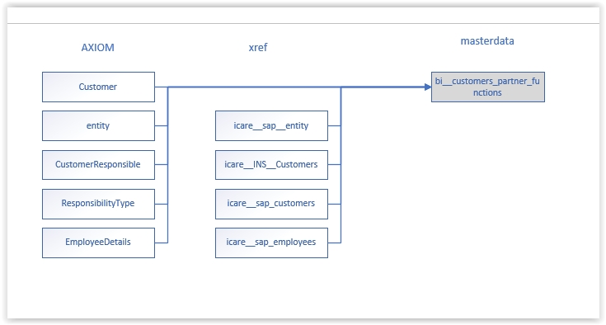

#### bi__distribution_channel

This table is sourced from AX and PCM

AX

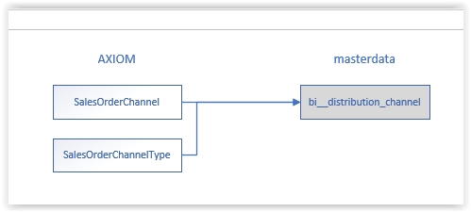

PCM

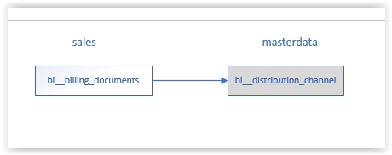

#### bi__delivery_priority_description

This table is sourced from AX

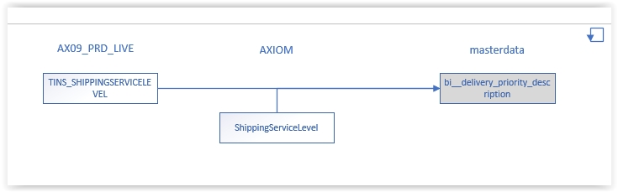

#### bi__employees

This table is sourced from two places AX and SAP:

AX

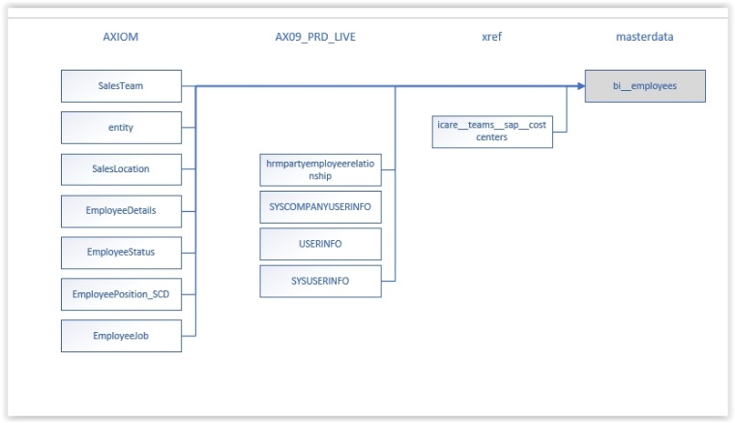

SAP

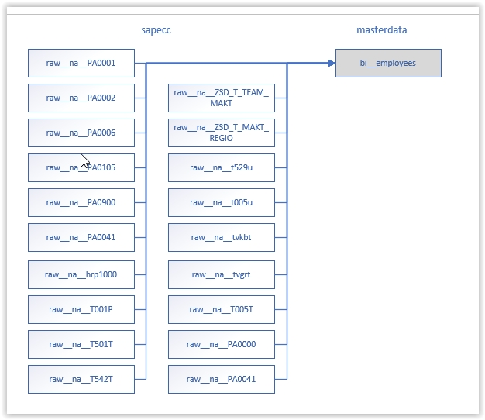

#### bi__employees_features

SAP

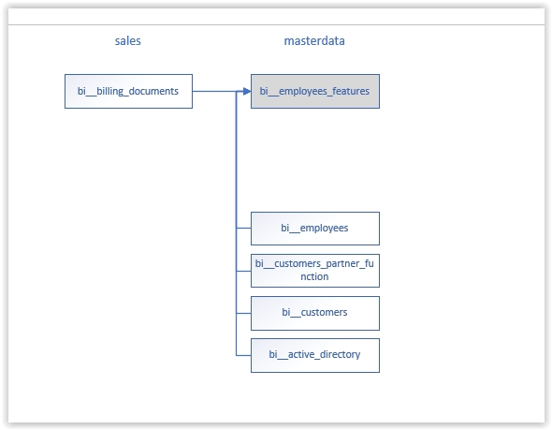

#### bi__employees_historical

SAP

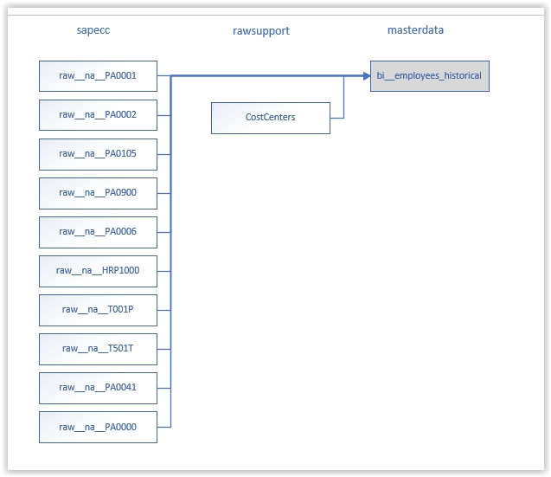

#### bi__general_ledger_to_pl

This enhanced table is sourced from support tables

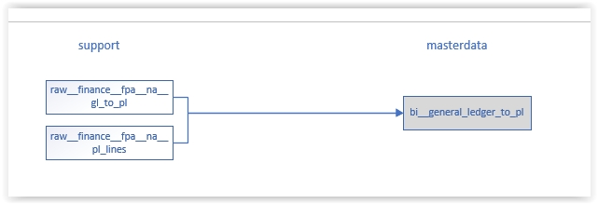

#### bi__ggps

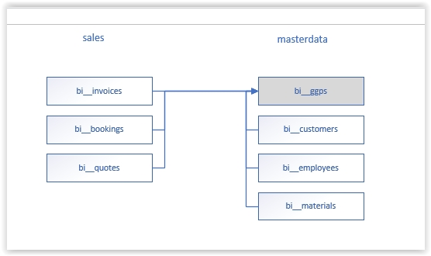

#### bi__manufacturers

bi__manufacturers is sourced from merged sources SAP, Alliance and PCM

Alliance

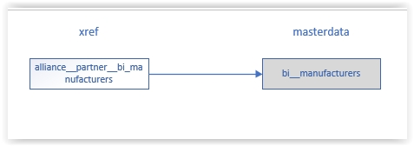

PCM

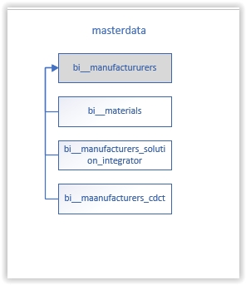

SAP

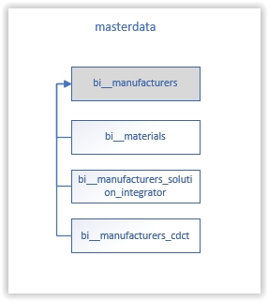

#### bi__materials

bi_materials is sourced from merged sources Alliance, AX, PCM, and SAP

Alliance

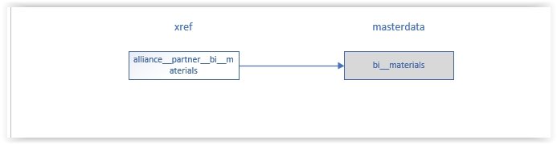

AX

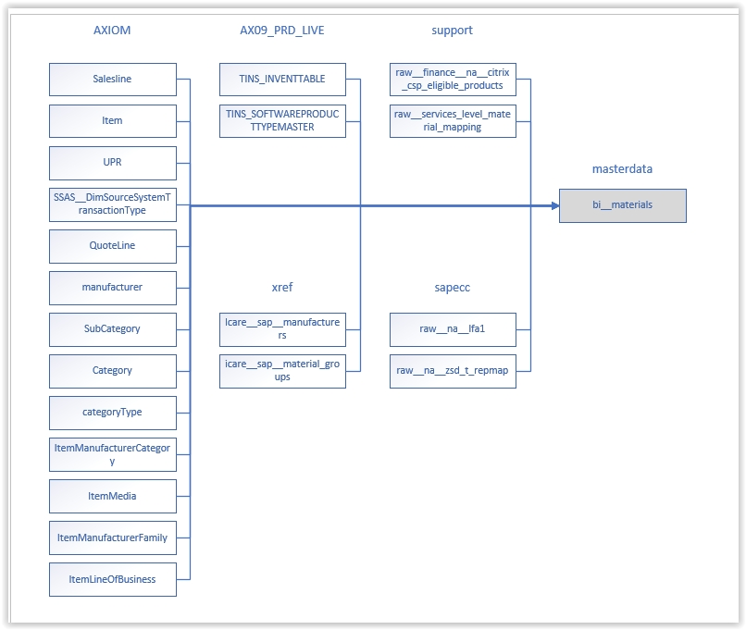

PCM

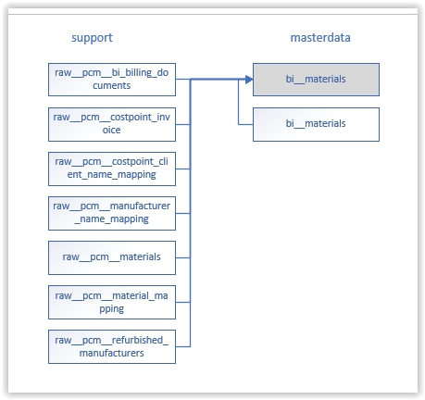

SAP

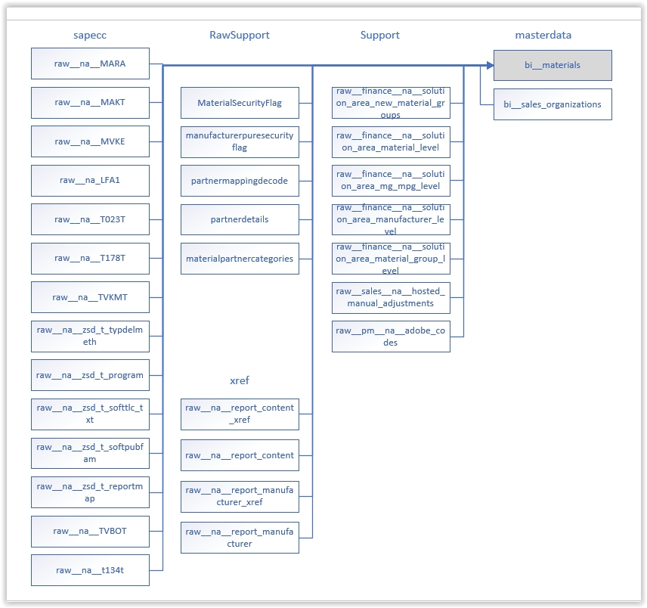

#### miscellaneous bi_ tables sourced from sapecc

SAP

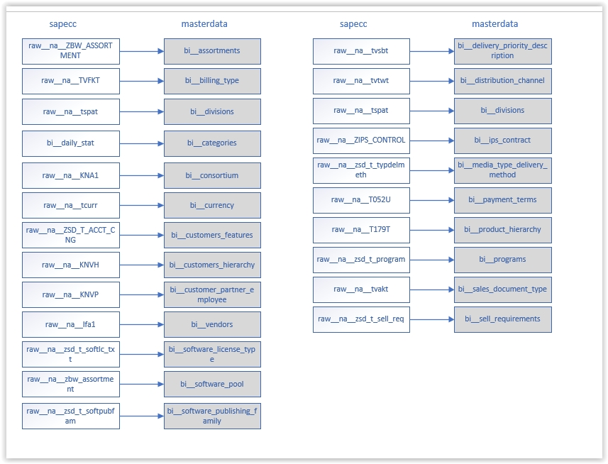

#### miscellaneous bi_ tables (sourced from finance)

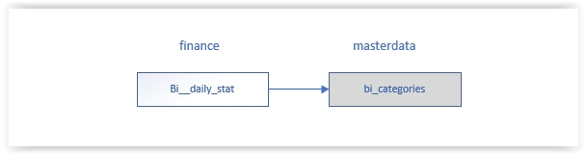

#### miscellaneous bi_ tables (sourced from masterdata)

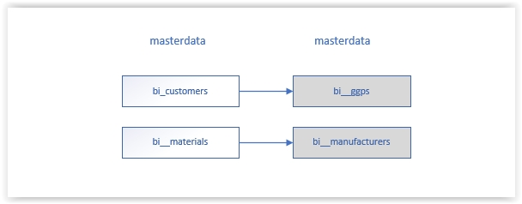

#### miscellaneous bi_ tables (sourced from support)

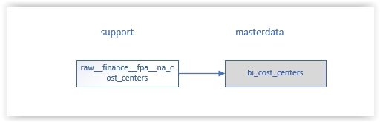

#### bi__profit_centers

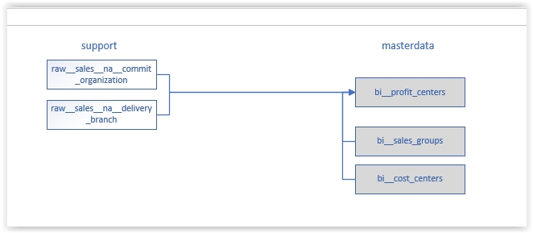

#### bi__sales_organizations

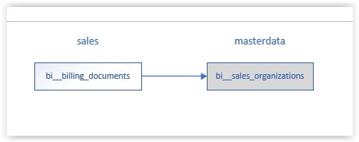

#### bi__sample

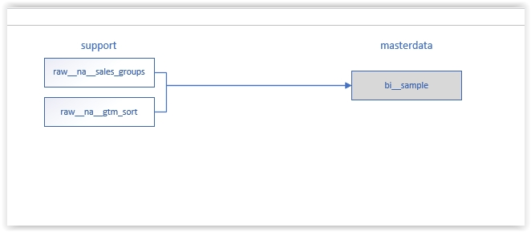

#### bi__soldto_partner

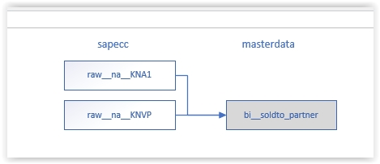

### Microsoft [Sanjay Tanneeru]

This database contains data sourced from Microsoft datastreams. It includes enhanced tables which are regularly updated. Data is sourced from a range of APIs and manual sources:

|  |  |  |  |
| --- | --- | --- | --- |
| **Feed** | **Note** | **Raw names** | **BI names** |
| Explore.ms | Manual source via scraper | Raw__explore__* | bi__explore__* |
| Partnercenter Insights API |  | Raw__pc__insights__* | - |
| Partnercenter Payouts API | NA/APAC data only at moment of writing | Raw__pc__payouts__* | - |
| Partnercenter CSP API | Feeding from instanced ELD servers at moment of writing | Raw__isams_ila__{instance}__azure_* | Bi__azure_* |
| Azure EA Billing API | Feeding from instanced ELD servers at moment of writing | Raw__isams_ila__{instance}__azure_ea_* | Bi__azure_ea_* |
| [Graph API](https://docs.microsoft.com/en-us/graph/api/resources/report?view=graph-rest-1.0) | beware: some endpoints contain the userprincipalname (email adres) which may be PII | Raw__isams_ila__{instance}__graph__* | Bi__graph_* |
| [Azure Retail Prices API](https://adb-5899215808800464.4.azuredatabricks.net/?o=5899215808800464#notebook/1262156349118788/command/1262156349118789) |  | Raw__azure__retail_prices | - |
| [Referrals API](https://docs.microsoft.com/en-us/partner/develop/referrals) | To be added Q2-Q3 2022 | Raw__pc__referrals__* | bi__pc__referrals_* |

#### Explore.ms

The explore data Is the vital collection of Microsoft Volume Licensing contract data. The source is scraped from <https://explore.ms> where scheduled reports are available for daily download. Each report constitutes a single table, and is set for a fixed time for creation to begin. This will take an unknown amount of time when data is preset by MSFT. An email notification can be triggered by explore. When the report is available, a download link appears and you can download an xls file. Download file records are limited to 300K lines only (might be old data on my part).

Access to explore is handled via user account, linked to one or more PCN Numbers. The account used by US BI has access to all PCN numbers of Insight and PCM, therefore able to pull global data.

The tables we download here are:

|  |  |
| --- | --- |
| **Table Name** | **What does it hold?** |
| Agreement | All volume licensing contracts (1 row = 1 contract) |
| AgreementOffering | Offering level per license pools on a contract |
| Amendment | All amendments tied to a contract |
| FutureBilling | Preset item lists for upcoming anniversaries |
| InvoiceDetail | All invoices to microsoft on volume licensing contract |
| pricelist | EA and EAS pricelists per month per pricelist type |
| PODetails | All purchase orders to microsoft on volume licensing contracts |
| SpecialPricing | All negotiated (fixed) pricings agreed upon on the contract |
| SABenefit | Software Assurance benefits tied to Enterprise contracts |
| TrueUp | List of dates for upcoming anniversaries / true ups |

**Latency requirement**: At most 5 day latency of live data in explore, and we will require lifetime data on all but pricelist. That needs to have trailing 6 years of data.

The explore data is also the foundation of a select number of derivative tables

|  |  |
| --- | --- |
| **Table Name** | **What does it hold?** |
| [InvoiceDetail_Discount](https://adb-5899215808800464.4.azuredatabricks.net/?o=5899215808800464#notebook/1162827535951902/command/1162827535951904) | Metatable that calculates the discount a customer has received on an item (LCS Enterprise benchmarking) |
| [SPLA Compliancy checks](https://adb-5899215808800464.4.azuredatabricks.net/?o=5899215808800464#notebook/1526144665877671/command/1526144665877672) | Metatable that calculates compliancy issues for SPLA enrollments (application of business logic) |
| [Product Families](https://adb-5899215808800464.4.azuredatabricks.net/?o=5899215808800464#table/microsoft/raw__explore__product_families) | Holds a product_family (Invoicedetails) to family relation |
| [Product Categories](https://adb-5899215808800464.4.azuredatabricks.net/?o=5899215808800464#table/microsoft/raw__explore__product_topcategories) | Holds a family to top category relation |

#### Partnercenter Insights API

The Insights dashboard is a unified reporting dashboard in Partner Center for Microsoft Commercial partners who are enrolled in the Microsoft Partner Network (MPN) program. The Insights dashboard provides 360-degree view of your key performance indicators (KPIs) across Cloud products such as Office, Azure, Dynamics, and licensing models such as Cloud Solution Provider (CSP) and Enterprise Agreement (EA). It exposes a rich set of KPI reports that can help you make data-driven decisions for your organization. The feed has the below endpoints, current being managed by Sanjay Tanneeru in BI:

|  |  |
| --- | --- |
| **Table Name** | **What does it hold?** |
| Customers Tenants | Base customer table from MSFT. Holds Customer TPID, Tenant ID, and tied billed revenue (USD) on sku level per month |
| Azure Usage | The Azure Usage report presents metrics related to your customers' Azure subscriptions including Azure consumption revenue and usage by meter categories. |
| dynamics usage | Dynamics active usage per sku |
| ems usage | Enterprise Mobility workloads active usage per sku |
| office usage | Office 365 workloads active usage per sku per month |
| power bi usage | Power BI workloads active usage per sku per month |
| seats | Subscriptions and seats counts in M365 per month |
| teams usage 3p apps | Teams 3rd party application usage per month per tenant |
| teams meetings calls | Teams Meeting counts and durations per tenant per month |
| teams workload | Teams participants per sub workload per month |

### Operations [Mark Dilly]

This database contains datasets processed and used in daily operations like pricing, timesheets, open purchase orders.data

#### bi__daily_pricing_combined

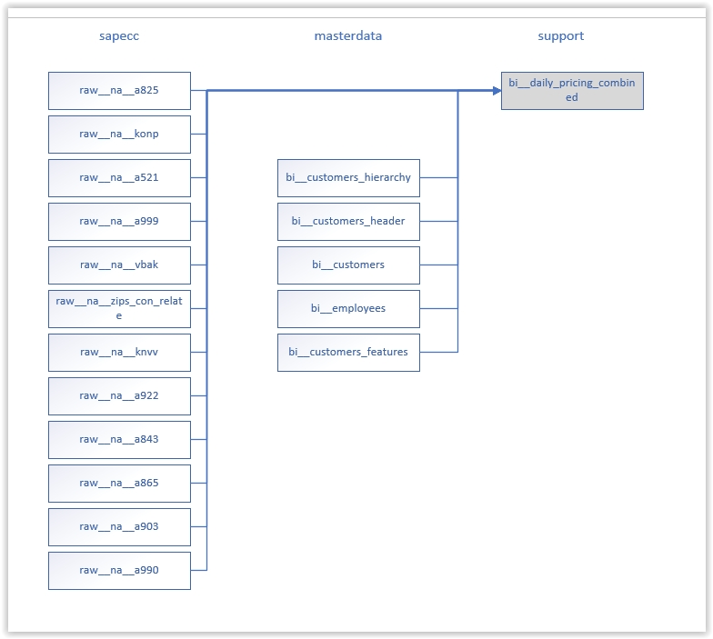

#### bi__daily_pricing_sw_addr

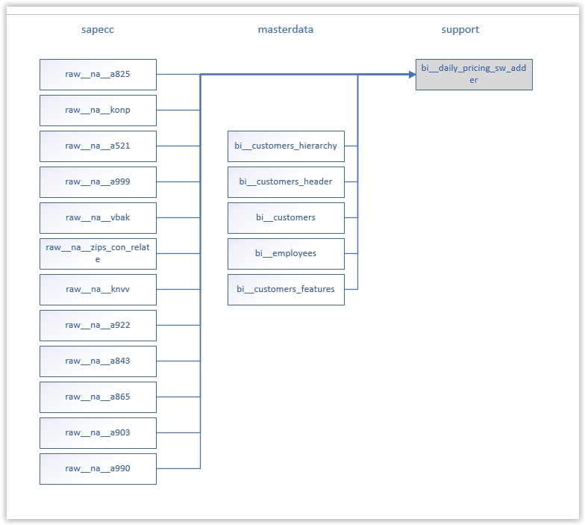

#### bi__edid4

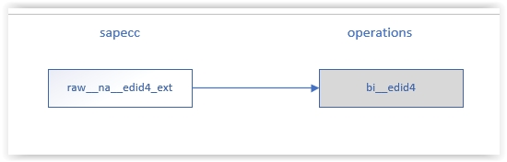

#### bi__idocs

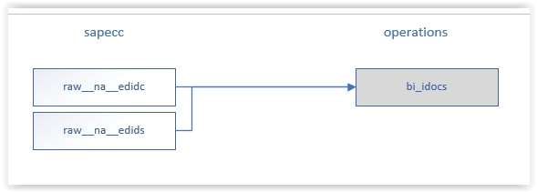

#### bi__open_gr

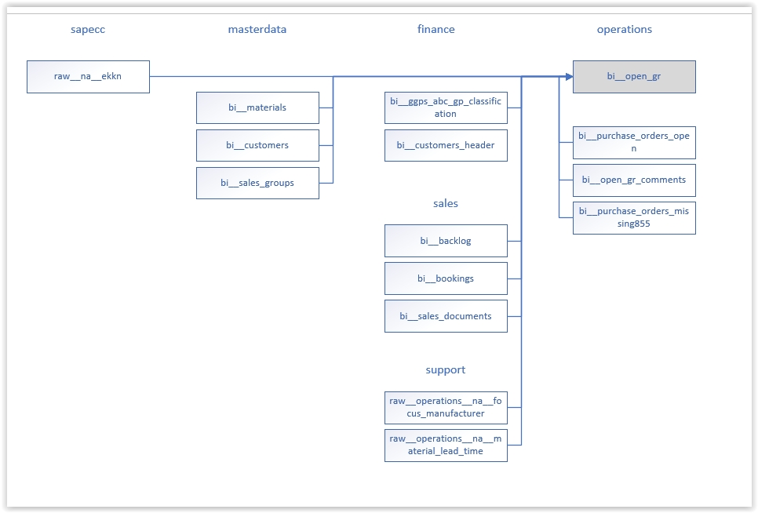

#### bi__open_gr_comments

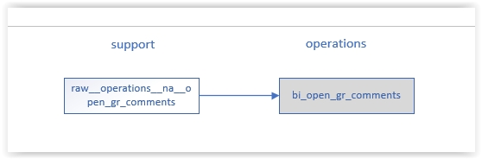

#### bi__outlook_clientops_emails

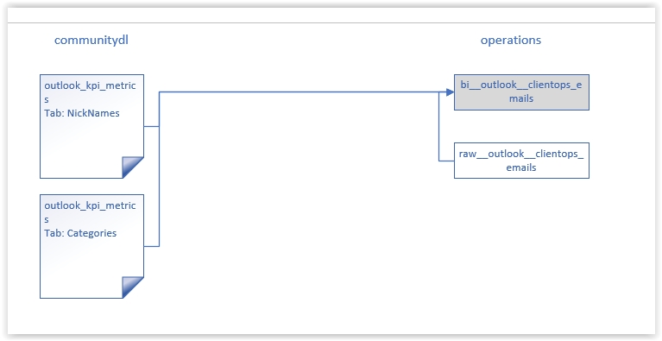

#### bi__production_orders_statuses

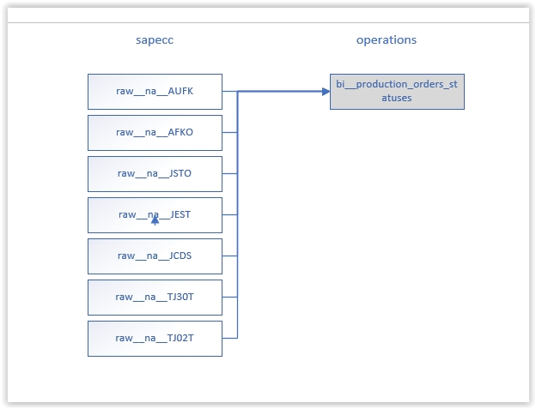

#### bi__purchase_orders

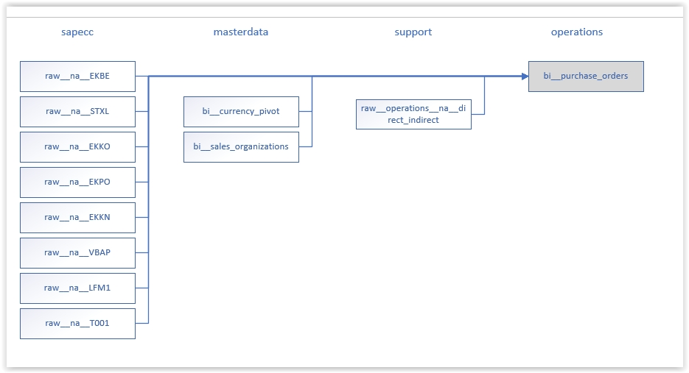

#### bi__purchase_orders_missing855

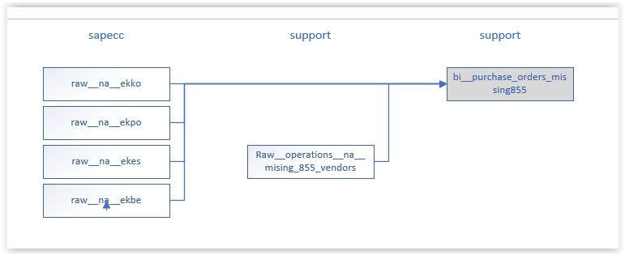

#### bi__purchase_orders_open

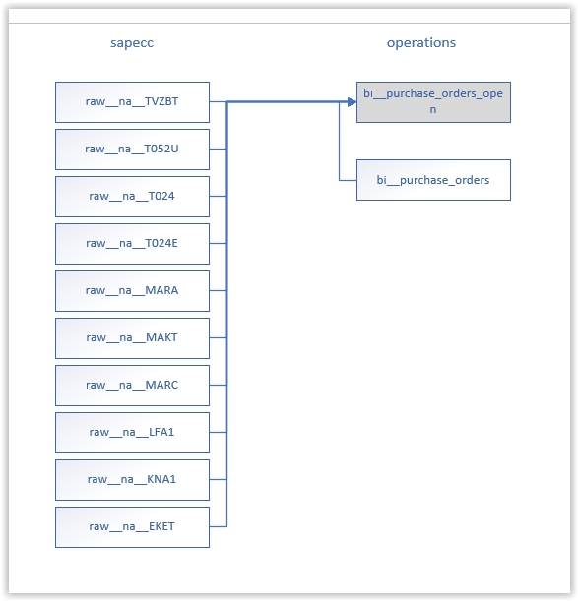

#### bi__time_sheet

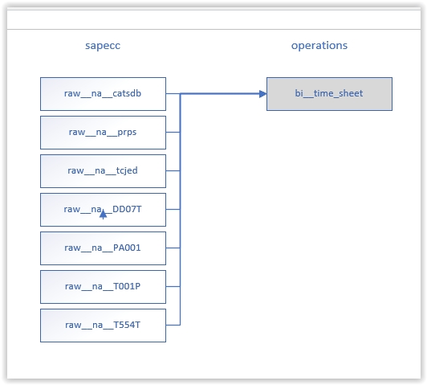

### Sales [Mark Dilly]

This database contains transactional sales data including quotes, orders, and billing

#### bi__adrc

AX

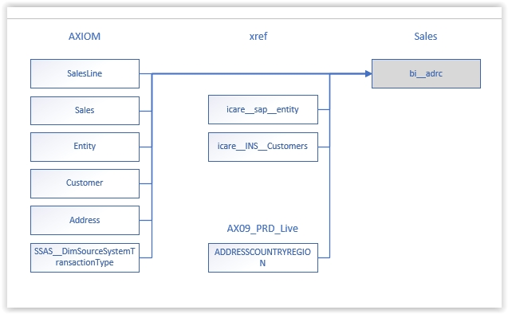

SAP

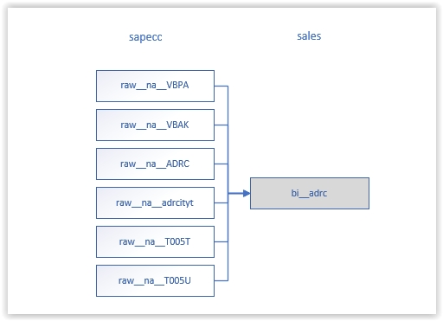

#### bi__backlog

This data is sourced from SAP.

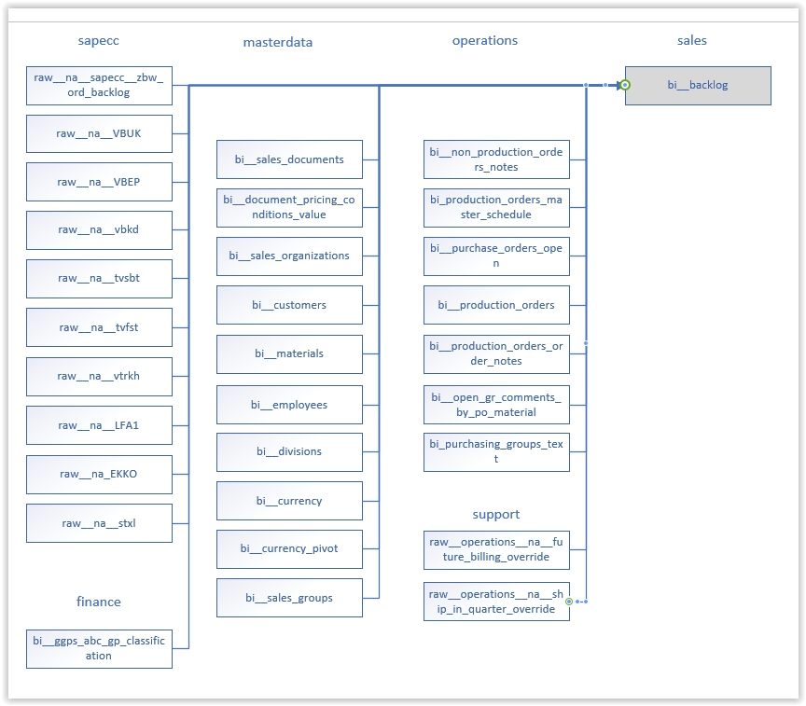

#### bi__billing_documents

This data is sourced from several places including alliance, AX, PCM and SAP

Alliance

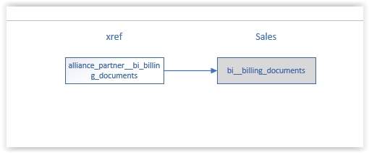

AX

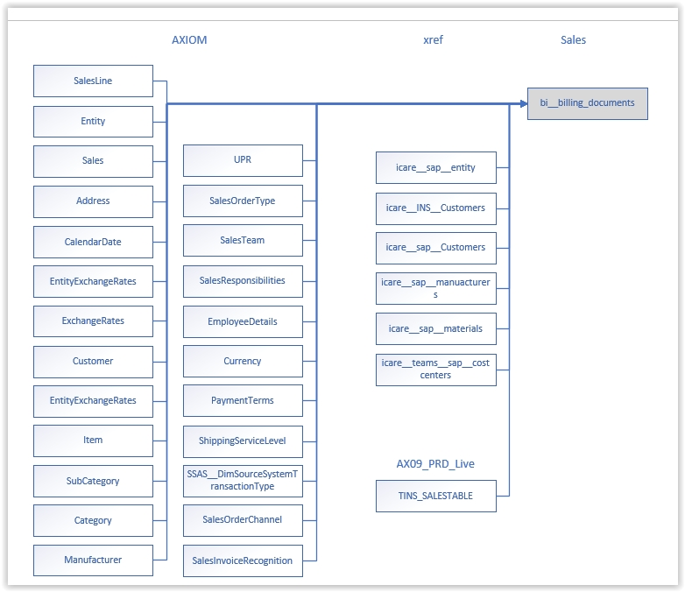

PCM

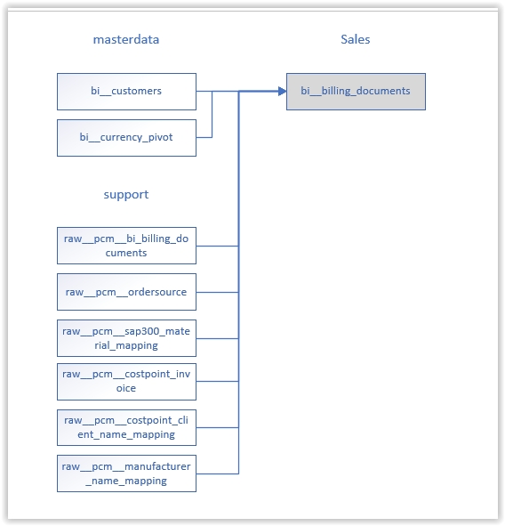

SAP

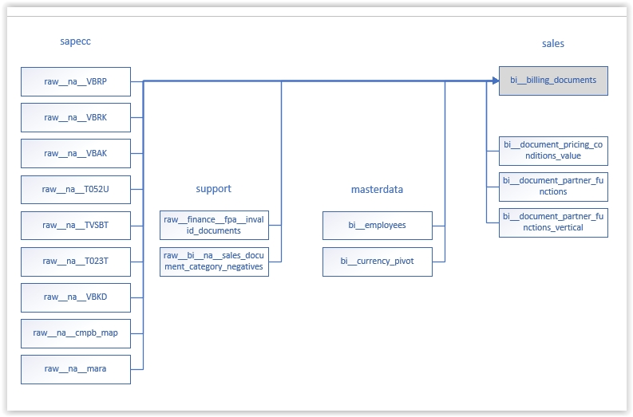

#### bi__customers_active

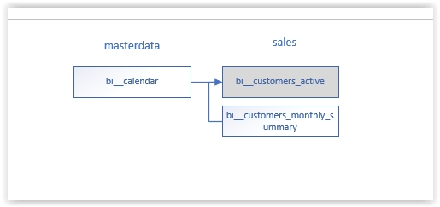

#### bi__customers_active_detail

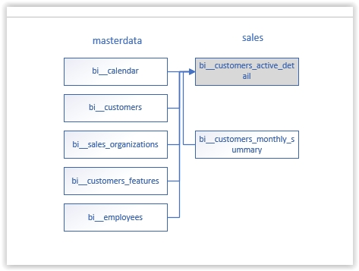

#### bi__customers_monthly_summary

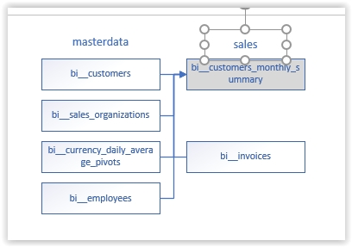

#### bi__customers_netnew

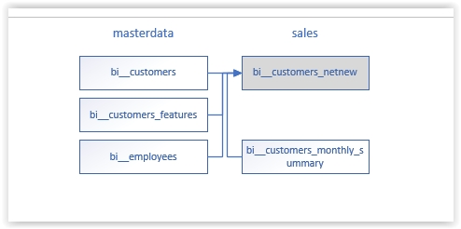

#### bi__customers_netnew_ecommerce

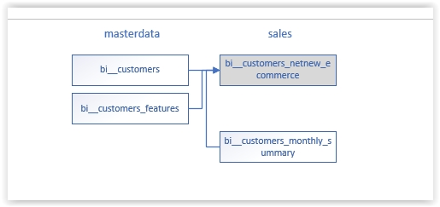

#### bi__dealreg

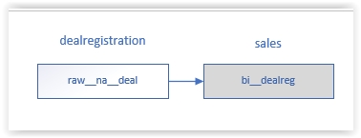

#### bi__delivery

AX

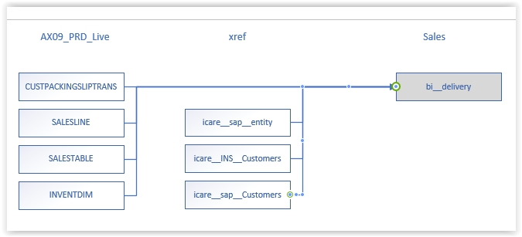

SAP

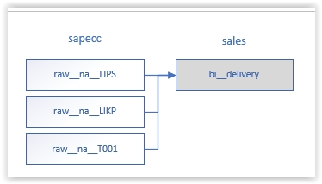

#### bi__delivery_serial_numbers

AX

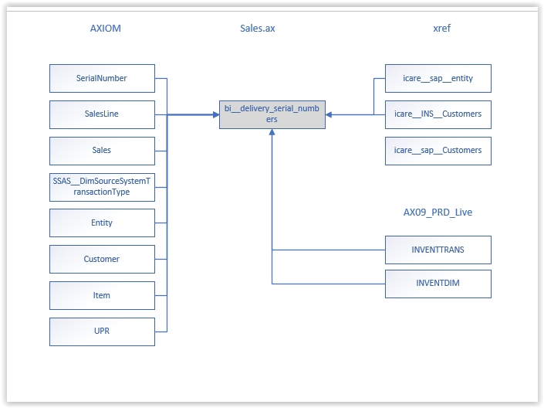

SAP

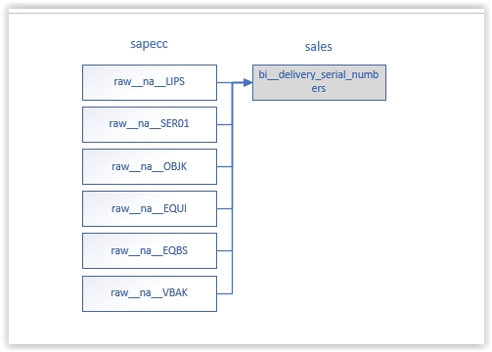

#### bi__document_partner_functions

This data is sourced form AX and SAP.

AX

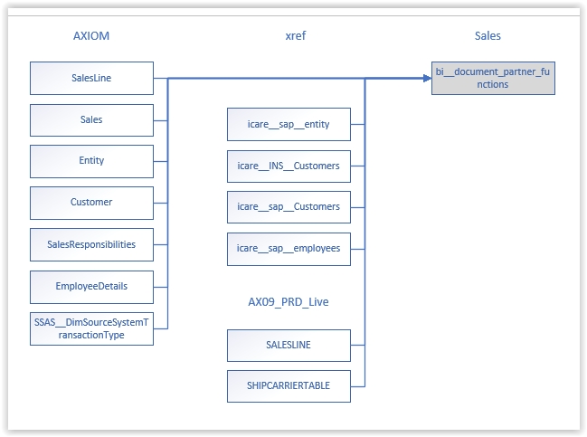

SAP

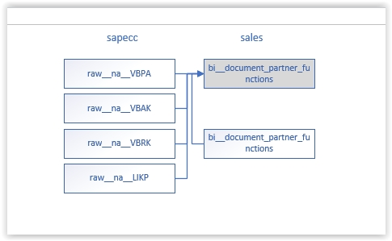

#### bi__document_partner_functions_vertical

This data is sourced from AX and SAP.

AX

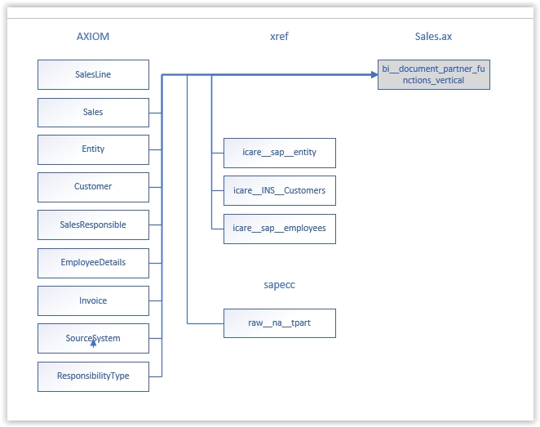

SAP

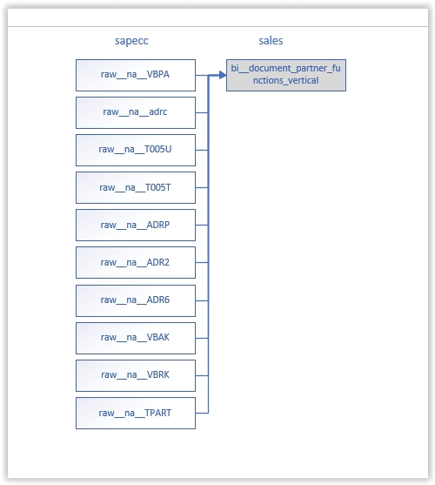

#### bi__document_pricing_conditions

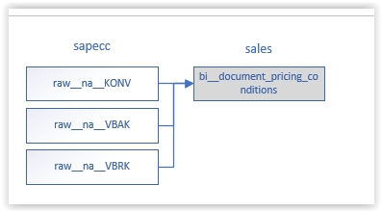

#### bi__email

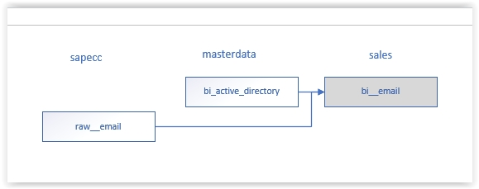

#### bi__invoice_serial_numbers

This data is sourced from AX and SAP.

AX

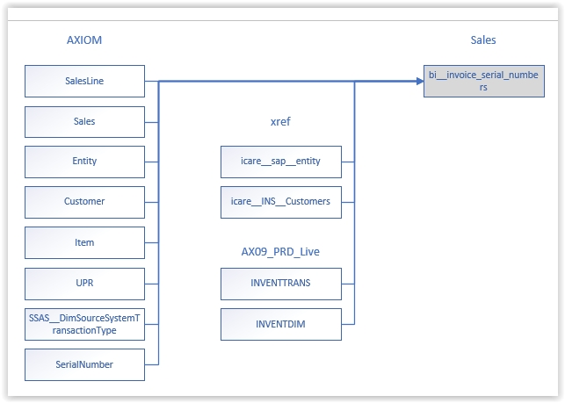

SAP

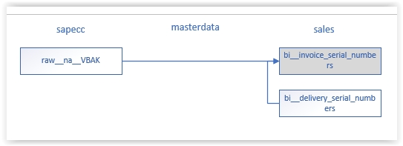

#### bi__order_cycle

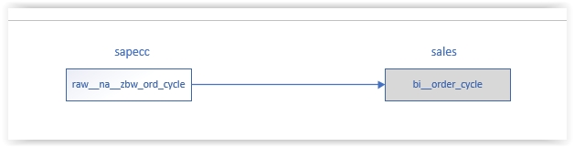

#### bi__order_cycle_unpivot

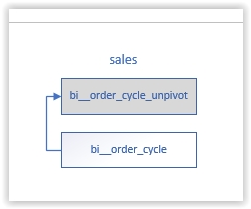

#### bi__order_schedule

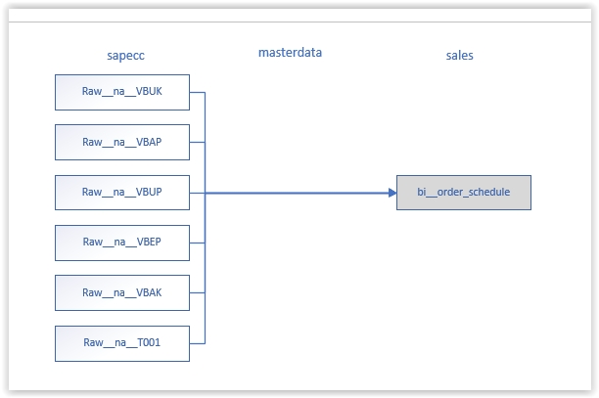

#### bi__phone_data

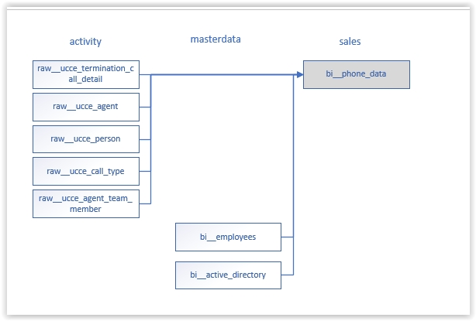

#### bi__pricing_conditions_value

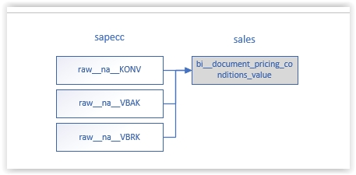

#### bi__renewals

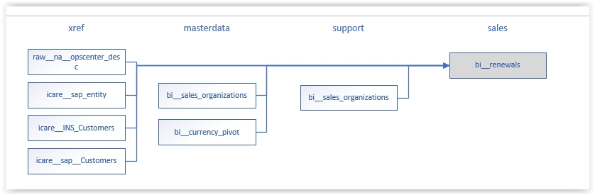

#### bi__sales_daily_ticker

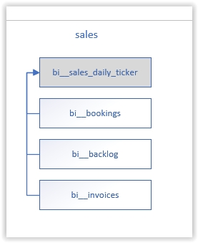

#### bi__sales_documents

This data is sourced from AX, PCM and SAP.

AX

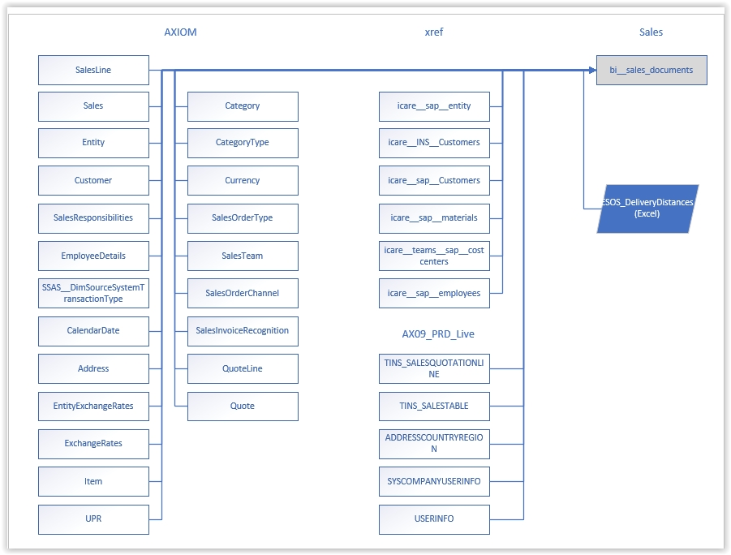

PCM

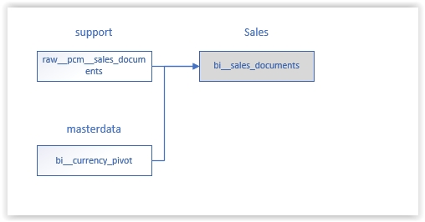

SAP

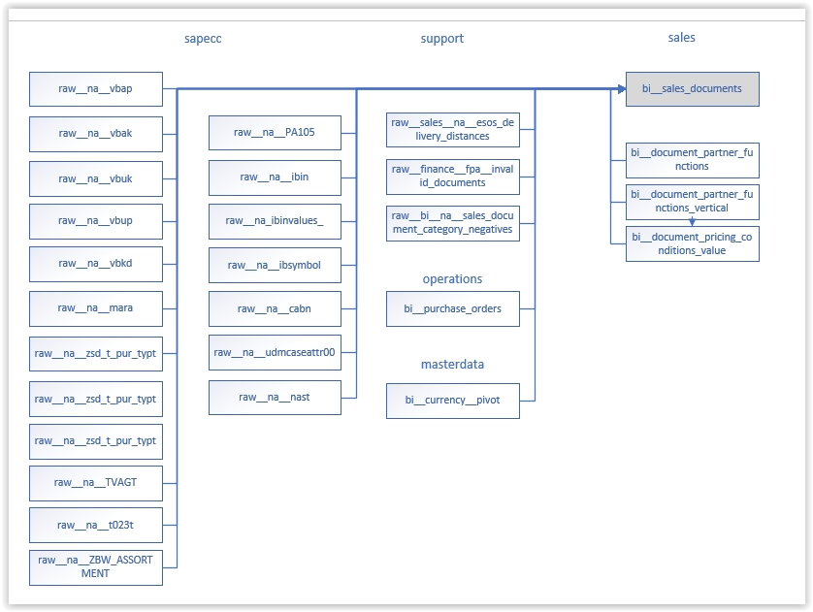

#### bi__smarttracker

This data is sourced from AX and SAP.

AX

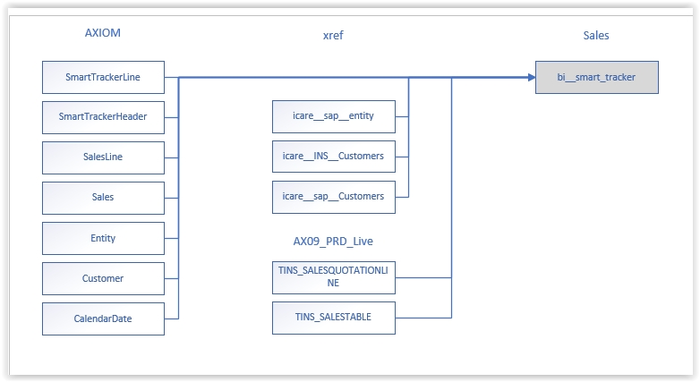

SAP

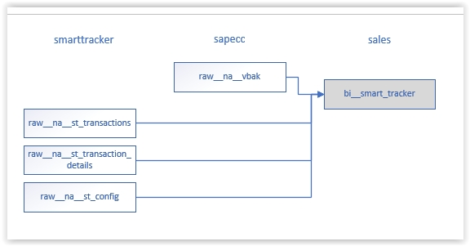

#### bi__tracking_pod

This data is sourced from AX and SAP.

AX

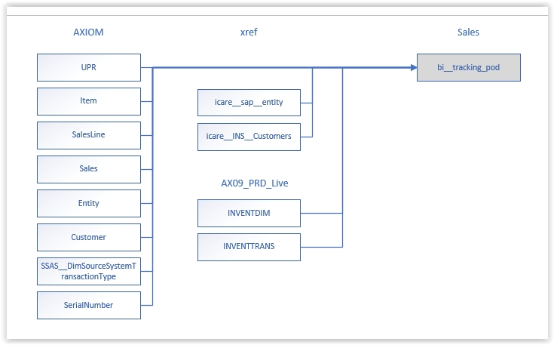

SAP

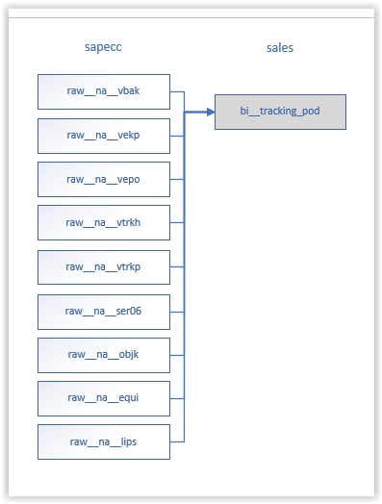

### servicenow [Mark Dilly]

This contains data captured from serviceNow ticketing instances. At present there are 3 system instances captured:

* datalink (or CDCT) Note: Datalink instance will be merged into servicesna instance in the near future.
* servicesna (global instance for North America)
* servicesca (Canada instance)

A daily “merge” process (a databricks job) populates the raw tables from tables in servicenow using the servicenow REST API. There is a Python “merge” notebook for each servicenow instance. Notebooks are scheduled to run daily and pull changed data since the previous run date. Using the API calls, updated and new rows are downloaded and merged with the records in the raw__* tables.

Data tables have the instance name embedded within to identify the data from each instance (system). Tables are prefixed with: raw__[Instance]__ and bi__[Instance]__. ”raw__” indicates data copied down as is from the servicenow tables, “bi__” indicates data enriched from the “raw__” tables (bi__ tables here will soon be removed and possibly replaced by other new enhancement processes).

Most smaller tables are the same format as those in servicenow. Other tables may contain a reduced set of columns. Since we don’t use every column in large tables, there is no need to download that data.

Table examples are:

raw__datalink__core_company

raw__servicesna__incident

raw__servicesca__cmn_location

## Data Exports to outside systems [TBD]

This section outlines various exports that are performed a on a regular basis that feed outside systems

### Totango

Totango is a customer success system that is being used to manage the client experience for Azure Products. Several types of data are processed into export formats, uploaded to communitydl and then subsequently uploaded to the AWS S3 bucket owned by Totango.

Files are generated and exported to: “communitydl/bi/Totango/export”

Files generated are:

customer.csv

contacts2.csv

Products.csv,

“Product Detail”.csv

These files are then transferred to Amazon Web Services (AWS) S3 bucket for consumption by Totango.

### TBD

## Currency Conversion [Mark Dilly]

Currency conversion becomes necessary when you report on Sales attributes that cross country or region boundaries, and have requirements render in a particular currency, “USD” for instance.

We have created a view for this purpose:

Masterdata.bi__currency_pivot

example use:

We need to calculate Total sales for a customer in USD to report sales for Insight North America (Insight NA). We have some source values in Canadian “CAD” currency.

To do this, we must “join” the view to get currency rate multiplier (i.e. “USD”)by the ***date of the transaction and the source currency*** (i.e. “From” column). There are currently 16 conversion rate currencies in the view. We can then use the (CAD, AUD, etc…) values returned as the multiplier on the original amount.

See the view in the masterdata data named “bi__currency_pivot”

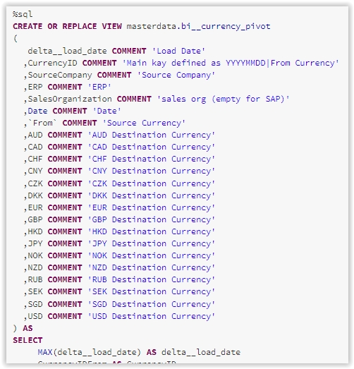

This view contains conversion rates for the above currency types by date.

To use it, we need to join the view on the following columns:

sourceCompany

ERP

SalesOrganization

From

Date

An example might be like this:

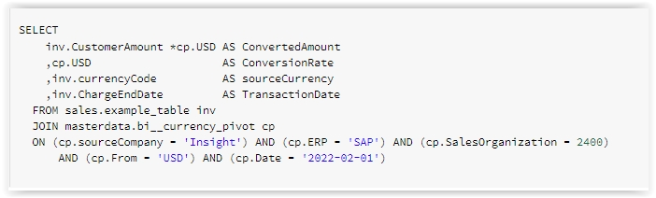

## SoldTo Uniqueness [Mark Dilly]

The Fusion project, which combined Sales data from EMEA and other regions with Insight North America, specifies new requirements to uniquely identify a particular customer by SoldTo number. The SoldTo number is no longer enough to identify a customer, since there is the possibility of duplicate SoldTo in different sources, ERP systems and Sales Organizations.

To uniquely identify a customer in the bi__customers table, you now must join several columns in bi__customers:

1. SourceCompany (“Insight”, “Insight EMEA”, “PCM”)
2. ERP (i.e. “AP”, “AX”, etc …)
3. SoldTo (10 digit number with preceeding 0’s i.e. “0011268960”)
4. SalesOrganization (i.e. 2400, 4100, etc …)
5. Delta__deleted must be equal to 0 for valid entries

Or if the table has a SoldtoID already, use that to join. If not you need to build the combined *SoldtoID* in your join condition as outlined above., you can join on the SoldToID column with the values combined:

“Insight|SAP|0011268960|2400”

Here is an example of building the ID in a join:

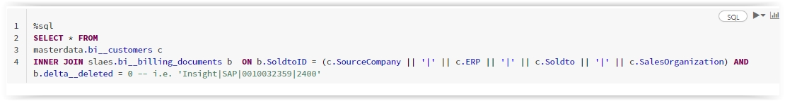

## Datalake (Blob) Storage [Done]

Within the datalake there are blobs containing folder hierarchies that corresponds to the database names. Within communityDL, these folders are used for reading and writing files. It can be used for import/export of files and configuration files. The example below shows a listing of folders available within communitydl.

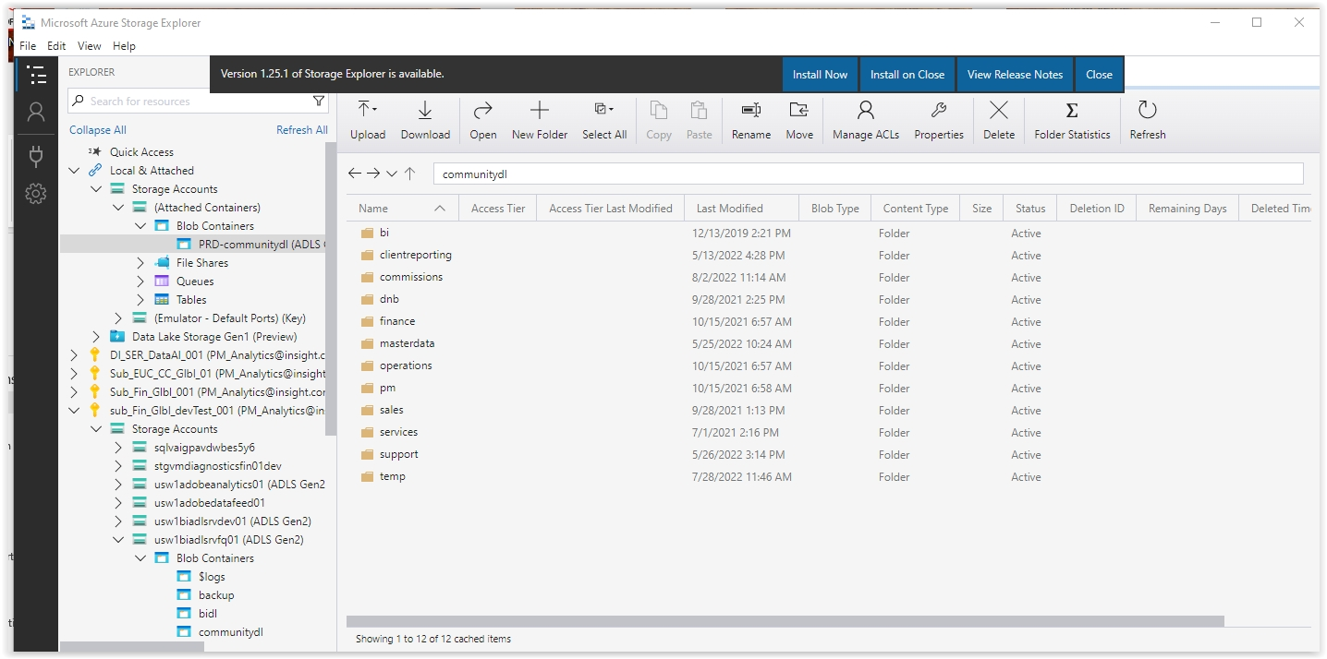

Within the “bi” folder, there are folder locations for various processing areas that roughly identify with the databases…

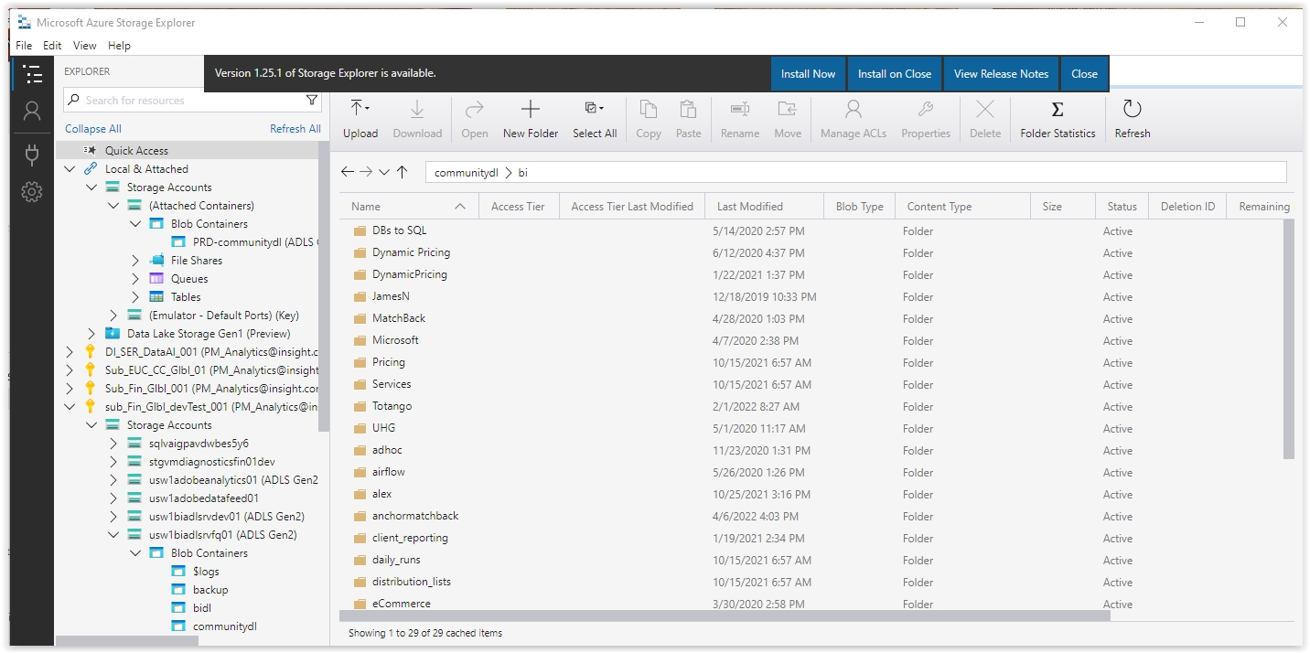

## Repos Folders

Repo folders generally match one for one with the databases created in Databricks. See the database section.

### Folder Conventions [done]

Repo folders are named in the following format:

[bi]-[databasename]

[bi] – is for the Business Intelligence group, it is anticipated other groups will be added here.

[database] – name of the database in databricks

Examples:

“bi-finance”

“bi-microsoft”

“bi-servicenow”

# Jobs [TBD]

We should discuss here the most important jobs (at least). i.e. The jobs that control when Sales tables get updated, masterdata etc..

TBD…

## job notebook

bi_­optimize_tables

bi_reportingcubes_views_creates

c4c_DAILY_RAW_TABLES

Job_bi_DailyLoads

TBD…

## Job configuration file

## Job scheduling

## Clusters

## Performance

### Streaming

### Optimization

## Failures and Troubleshooting

# Reports [Done]

Two different types of reporting are used at this time… PowerBI and Paginated Reports.

PowerBI

A Power BI report is **a multi-perspective view into a dataset**, with visuals that represent different findings and insights from that dataset. A report can have a single visual or pages full of visuals.

Paginated Reports

These reports are formatted to fit well on a page to be printed or shared.

Currently paginated reports must use an ODBC driver connection to databricks. This has some limitations in that the normal SQL query capability with parameters is severely limited for joins and parameters. See below for more details.

## PowerBI Reporting

### Data Models

### Data refreshes

## Paginated reporting

We have found that it can be done using “expression” and a prepared view or table. The expressions allow you to format parameter values using the SSRS functions and format. If you have multiple join requirements it is best to create a table/dataset rather than a view for performance reasons.

There are various examples you can review like: NA & APAC . PM . Sales Out

## Workspaces [Mark Dilly]

### :BI

This workspace contains reports related to:

* Usage
* Audit
* Security Group

### :BI Accounting and Finance

### This workspace contains report related to:

* GL
* Legal- Audits
* AP
* AR
* Accounting
* Partner Accounting

### :BI Client Reporting

This workspace contains reports related to:

* Client Facing reports

### :BI CMD

This workspace contains reports related to:

* Client Master Data

### :BI HR

This workspace contains reports related to:

* Diversity
* Employees

### :BI Marketing & e-commerce

This workspace contains reports related to:

* Marketing

### :BI Models

This workspace contains powerbi models and datasets

### :BI PM & Sales

This workspace contains reports related to:

* Commissions
* Sales Out
* Metrics / Scorecards
* Matchback
* Rep info
* Account Info

### :BI Operations

This workspace contains reports related to:

* Lab
* Warehouse
* Hybris Reports
* EDI
* Ticketing = Internal
* Purchasing

### :BI Services

This workspace contains reports related to:

* Internal/Operational
* Financial
* Service Now / Ticketing External

# Data Science and Machine Learning [Joseph Abramson]

## Use of Databricks

The MS Azure Databricks Portal provides a set of tools for Data Science and Machine Learning in the broad sense. Problems that can be solved with these tools include the following: Regression, Dichotomous Classification, Multi-class Classification, Image Classification, Recommendation, Clustering, Text Analytics, and Anomaly Detection. The algorithms for these methods are contained in several libraries which are pre-installed in the Dev01-BI-ML-StandardCommunity cluster. Selection of the best algorithm requires some knowledge of Machine Learning and should ideally be done in consultation with one of the Data Scientists at Insight, Inc.

## Personas

The MS Azure Databricks Portal presents two “personas” for this purpose: (1) Data Science and Engineering, and (2) Machine Learning. In both personas the user can gain access to the ML functionality from a Jupyter Notebook.

The Data Science link is here: [https://adb-5899215808800464.4.azuredatabricks.net/?o=5899215808800464#](https://adb-5899215808800464.4.azuredatabricks.net/?o=5899215808800464). The Machine Learning link is here: <https://adb-5899215808800464.4.azuredatabricks.net/?o=5899215808800464#ml/dashboard>. Both pages provide links to documentation and tutorials.

Jupyter Notebooks support four programming languages: Python, R, Scala, and Databricks SQL. The first three are appropriate for Machine Learning work, while the last is useful for data access and management. The languages can be mixed within a single Notebook, one language per cell. This allows the user to extract raw data from a Databricks repository (such as a Delta table using SQL or a flat file residing on the Databricks File System using straight R or Python). Here is an example using the R language:

* 1. Create an SQL query in the notebook to select some data from the Databricks Modern Data Architecture. Store the results in a view called MyData. This can be executed in a cell with SQL as the default language.
  2. Now, in the next cell (with R as the default language), execute the following code:

library(SparkR)

sparkR.session()

df1 = tableToDF("MyData")

This will create an R data frame (df1) containing all the data in the view. From this point on the user can apply Machine Learning models to the data as it will be in the correct tabular structure for the algorithms. Similar methods can be used for Python and Scala.

To write an R data frame to a Delta table in Databricks, use code like this:

library(SparkR)

sparkR.session()

table_name <- 'insight360.MyTable'

saveAsTable(

df = df1,

source ="delta",

tableName = table_name

)

It is also possible to upload a flat file from one’s laptop to the Databricks File System. This is most easily done from within a Notebook. Use the top menu to upload a file and then generate code to read the file into a data frame.

**Machine Learning**

ML Concept: Machine learning is an interdisciplinary subject combining computer science, statistics and domain knowledge (such as Business Management). It is the study of computer algorithms that learn from data, and in turn generating models which can make predictions or decisions. It is also known as statistical learning.

Categories: There are three categories of machine learning: (1) supervised learning, (2) unsupervised learning, and (3) reinforcement learning.

Databricks ML: Databricks Machine Learning (Preview) is an integrated end-to-end machine learning platform incorporating managed services for experiment tracking, model training, feature development and management, and feature and model serving.

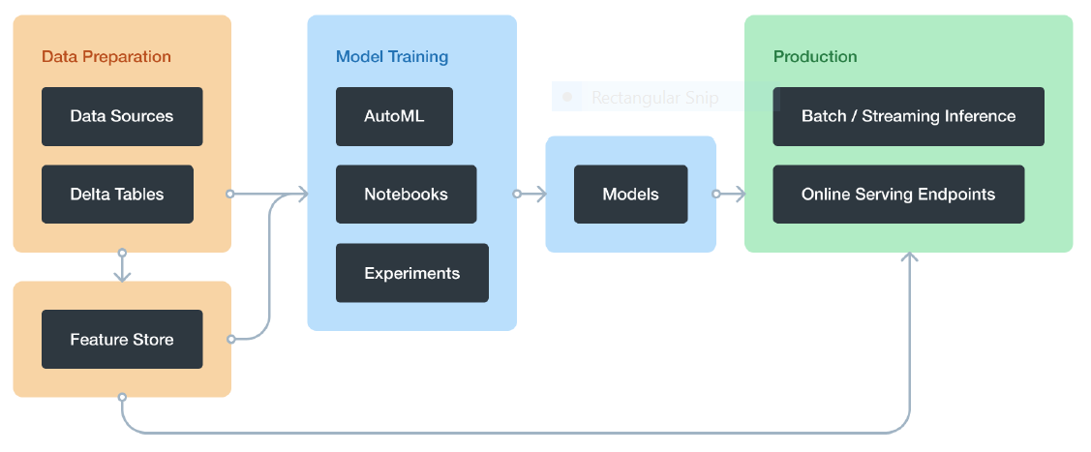

Databricks Machine Learning provides support for importation of ML libraries, dataframe operations, modeling and output storage.

Python Notes:

The Databricks Jupyter Notebook also supports interactive environments for Python. The first thing to do before writing in the notebook using python is to change the default Language to Python by clicking the icon beside the name of the notebook. Then we can do many things using the Python language:

1. Import data from sql query as spark dataframe:

df_spark = spark.sql("SELECT CONCAT(Cloud, ',', EnrollmentNumber,',', SubscriptionID, ',', PartnerAttributionType) as obs, ConsumptionMonth, Consumption, IncentiveRate FROM insight360.cloud__monthlyspend_t60m m")

Convert spark dataframe to pandas dataframe:

data_df = df_spark.toPandas()

1. Data operation such as filtering, grouping, dropna, etc.
2. Arithmetic operators on arrays using NumPy library.
3. Building machine learning models using sklearn library

# Appendix

## Acronyms

APAC - Asia Pacific operations (Insight)

AR – Accounts Receivable

BI – Business Intelligence

CDCT - Cloud and Data Center Transformation (as in services)

CMD - Customer Master Data

COPA - SAP Profitability Analysis

CRM - Customer Relationship Management system (used by Sales)

CWF - Current Work Force (as in services)

DNB - Dun & Bradstreet (a supplier that categorizes/identifies companies/sales/markets)

EA - Enterprise Agreement (as in Microsoft, or Cisco agreements)

ELD - Enterprise License Dashboard (Insight Microsoft database)

EMEA - Europe, Middle East, Africa operations (Insight)

ERP - Enterprise Resource Planning (i.e. SAP, Dynamics, etc)

ETL – Extract, Transform, Load

GGP - Great Grand Parent (parent company of a Soldto)

Hybris - SAP product content management)

IaaS – Infrastructure as a Service

ICA – Insight Canada

IPS - Insight Public Sector

IUS – Insight US

MDA – Modern Data Architecture

MSFT - Microsoft

MTC - My Teammate Central

NA - North America operations (Insight)

OneCall - services offering (ticketing) in CDCT

PaaS – Platform as a Service

POSS - Pre-Order Sales Support

SaaS – Software as a Service

SSAS – SQL Server Analysis Services

SSIS – SQL Server Integration Services

SSMS – SQL Server Management Studio

SSO – Shared Service Organization

SCO - Software Supply Chain Optimization

SMART - Cisco related SmartNet contracts (warranty)

WBS - Work Breakdown Structure (SAP)

## Other Terms and Definitions

**Azure Databricks** - Azure Databricks is a data analytics platform optimized for the Microsoft Azure cloud services platform. Azure Databricks offers three environments for developing data intensive applications: Databricks SQL, Databricks Data Science & Engineering, and Databricks Machine Learning

**Apache Spark** - Many data scientists, analysts, and general business intelligence users rely on interactive SQL queries for exploring data. Spark SQL is a Spark module for structured data processing.

**Data Lake** - A central location that holds a large amount of data in its native, raw format, as well as a way to organize large volumes of highly diverse data.

**Dataframe** - A data structure that organizes data into a 2-dimensional table of rows and columns, much like a spreadsheet.

**Deep learning** - Deep Learning is a subset of machine learning concerned with large amounts of data with algorithms that have been inspired by the structure and function of the human brain, which is why deep learning models are often referred to as deep neural networks

**Git** - Git is a free and open source distributed version control system designed to handle everything from small to very large projects with speed and efficiency.

**Github –**  is a provider of Internet hosting for software development and version control using Git. It offers the distributed version control and source code management functionality of Git, plus its own features

**Parquet** - Parquet is an open source file format available to any project in the Hadoop ecosystem. Apache Parquet is designed for efficient as well as performant flat columnar storage format of data compared to row based files like CSV or TSV files

**Spark SQL -** Many data scientists, analysts, and general business intelligence users rely on interactive SQL queries for exploring data. Spark SQL is a Spark module for structured data processing.

**Unified Data Warehouse** - A unified database also known as an enterprise data warehouse holds all the business information of an organization and makes it accessible all across the company.